# INDEX

INDEX 2

LIST OF FIGURES 5

LIST OF TABLES 8

LIST OF ABBREVIATIONS AND ACRONYMS 9

LIST OF SYMBOLS 12

CHAPTER 1: INTRODUCTION 1

1.1 RELATED WORK 3

1.2 CLASSIFICATION MODEL 8

1.3 RESEARCH PROBLEM 10

1.4 HYPOTHESIS 11

1.5 OBJECTIVES 11

CHAPTER 2: SIGNAL AND SYSTEM MODEL 12

2.1 SYSTEM MODEL 12

2.2 PROPOSED METHOD 14

2.3 DOA ESTIMATION AS A CLASSIFICATION PROBLEM 15

2.4 METRICS AND SCORING 17

2.5 PARTIAL CONCLUSIONS 19

CHAPTER 3: IMPLEMENTATION OF THE SIMULATION SCENARIO 20

3.1 ANTENNAS COORDINATES 22

3.2 TRANSMITTER COORDINATES 23

3.3 DISTANCE BETWEEN TRANSMITTING ANTENNA AND RECEIVING ANTENNAS 24

3.4 ANGLES BETWEEN TRANSMITTING ANTENNA AND RECEIVING ANTENNAS 25

3.5 POWER RECEIVED ON EACH OF THE RECEIVING ANTENNAS IN THE SYSTEM 27

3.6 PARTIAL CONCLUSIONS 27

CHAPTER 4: RECEIVER SYSTEM DESIGN 29

4.1 DATA GENERATION 29

4.2 ANALYSIS OF AZIMUTH ANGLES FOR THE FIRST RECEIVER SYSTEM MODEL 33

4.3 ANALYSIS OF AZIMUTH ANGLES FOR THE SECOND RECEIVER SYSTEM MODEL 38

4.4 ANALYSIS OF AZIMUTH ANGLES FOR THE THIRD RECEIVER SYSTEM MODEL 41

4.5 ANALYSIS OF AZIMUTH ANGLES FOR THE FOURTH RECEIVER SYSTEM MODEL 45

4.6 ANALYSIS OF ELEVATION ANGLES FOR THE FIRST RECEIVER SYSTEM MODEL 47

4.7 ANALYSIS OF ELEVATION ANGLES FOR THE SECOND RECEIVER SYSTEM 50

4.8 ANALYSIS OF ELEVATION ANGLES FOR THE THIRD RECEIVER SYSTEM 53

4.9 ANALYSIS OF ELEVATION ANGLES FOR THE FOURTH RECEIVER SYSTEM 56

4.10 PARTIAL CONCLUSIONS 59

CHAPTER 5: SIMULATION 62

5.1 SIMULATIONS CONDITIONS 62

5.2 OPTIMIZATION OF MACHINE LEARNING MODELS 62

CHAPTER 6: CONCLUSIONS 63

APPENDIX A 64

References 65

# LIST OF FIGURES

Figure 1. Beamforming technique. 2

Figure 2. Overview of applications of ML in DOA [37]. 8

Figure 3. The System Model. 10

Figure 4. Flowchart of the implementation of the scenario. 20

Figure 5. Antennas coordinates. 22

Figure 6. Distance between transmitting antenna and receiving antennas. 24

Figure 7. Angle between the receiving antenna and transmitter antenna in the $xy$ plane. 25

Figure 8. First receiver model proposal. 29

Figure 9. Second receiver model proposal. 29

Figure 10. Pattern of the dipole antenna at 70 MHz frequency. 31

Figure 11. Pattern of the dipole Vee antenna at 70 MHz frequency. 31

Figure 12. Confusion matrix for the azimuth angles of the DT model trained with the data provided by the first receiving system. 33

Figure 13. Elevation angles versus a number of incorrectly predict azimuth angles in the first receiving system. 34

Figure 14. Scenario formed by four receiving antennas dipole and a transmitting source located at 8° azimuth angle and 53° elevation within the receiving system. 35

Figure 15. Radiation pattern of a dipole antenna. 35

Figure 16. Confusion matrix with the first 20 classes for the azimuth angles of the DT model trained with the data provided by the first receiving system. 36

Figure 17. Confusion matrix of the DT model trained with the data provided by the second receiving system. 37

Figure 18. Elevation angles versus a number of incorrectly predict azimuth angles in the second receiving system. 38

Figure 19. Confusion matrix with the first 20 classes of the DT model trained with the data provided by the second receiving system. 39

Figure 20. Confusion matrix of the DT model trained with the data provided by the third receiving system. 41

Figure 21. Azimuth angles versus a number of incorrectly predict azimuth angles in the third receiving system. 42

Figure 22. Scenario formed by four receiving antennas dipole Vee and a transmitting source located at 0° azimuth and 53° elevation angles within the receiving system. 42

Figure 23. Elevation angles versus a number of incorrectly predict azimuth angles in the third receiving system. 43

Figure 24. The radiation pattern of a dipole Vee antenna in xz-plane. 43

Figure 25. Confusion matrix of the DT model trained with the data provided by the fourth receiving system. 44

Figure 26. Azimuth angles versus a number of incorrectly predict azimuth angles in the fourth receiving system. 45

Figure 27. Elevation angles versus a number of incorrectly predict azimuth angles in the fourth receiving system. 46

Figure 28. Confusion matrix for the elevation angles of the DT model trained with the data provided by the first receiving system. 47

Figure 29. Elevation angles versus a number of incorrectly predict elevation angles in the first system. 48

Figure 30. Azimuth angles versus a number of incorrectly predict elevation angles in the first receiving system. 49

Figure 31. Confusion matrix for the elevation angles of the DT model trained with the data provided by the second receiving system. 50

Figure 32. Elevation angles versus a number of incorrectly predict elevation angles in the second receiving system. 51

Figure 33. Azimuth angles versus a number of incorrectly predict elevation angles in the second receiving system. 52

Figure 34. Confusion matrix for the elevation angles of the DT model trained with the data provided by the third receiving system. 53

Figure 35. Elevation angles versus a number of incorrectly predict elevation angles in the third receiving system. 54

Figure 36. Azimuth angles versus a number of incorrectly predict elevation angles in the third receiving system. 55

Figure 41. Confusion matrix for the elevation angles of the DT model trained with the data provided by the fourth receiving system. 56

Figure 38. Elevation angles versus a number of incorrectly predict elevation angles in the fourth receiving system. 57

Figure 39. Azimuth angles versus a number of incorrectly predict elevation angles in the fourth receiving system. 58

# LIST OF TABLES

Table 1. Taxonomy of the proposed ML to DOA estimation. 6

Table 2. Comparison of powers received by four dipole antennas in an ideal system and a system with noise. 34

Table 3. Comparison of powers received by five dipole antennas in an ideal system and a system with noise. 38

Table 4. Accuracy and MSE of the DT model with the data provided by the four proposed receiving systems. 60

# LIST OF ABBREVIATIONS AND ACRONYMS

|  |  |
| --- | --- |
| AWGN----------------------- | Additive White Gaussian Noise |
| BC---------------------------- | Bagging Classifier |
| BF---------------------------- | Beamforming |
| BS---------------------------- | Base Station |
| CRB------------------------ | Cramer-Rao Bound |
| CVNN------------------------ | Complex-Valued Neural Network |
| DNN-------------------------- | Deep Neuronal Network |
| DOA-------------------------- | Direction of Arrival |
| DT---------------------------- | Decision Tree |
| EDT ------------------------- | Extra Decision Trees |
| FBLP------------------------- | Forward–Backward Linear Prediction |
| HBF-------------------------- | Holographic Beamforming |
| IoT --------------------------- | Internet of Things |
| LL---------------------------- | Log-Likelihood |
| ML---------------------------- | Machine Learning |
| MLE-------------------------- | Maximum Likelihood Estimation |
| MMA------------------------- | Multi-Mode Antenna |
| MMP------------------------- | Multioutput-Multilabel Proposal |
| MPNN----------------------- | Multilayer Perceptron Neuronal Network |
| MSE-------------------------- |  |
| NN---------------------------- | Neuronal Network |
| RSS--------------------------- | Received Signal Strength |
| SNR-------------------------- | Signal-to-Noise Ratio |
| SOC-------------------------- | Second Order Cone |
| SP----------------------------- | Separate Proposal |
| SPMT------------------------ | Single-Pole-M-Throw |
| 6G---------------------------- | Sixth Generation |
| SSR--------------------------- | Sparse Signal Reconstruction |
| SVC-------------------------- | Support Vector Classification |
| SVD-------------------------- | Singular Value Decomposition |
| SVR-------------------------- | Support Vector Regression |
| UCA-------------------------- | Uniform Circular Array |
| ULA-------------------------- | Uniform Linear Array |
|  |  |
|  |  |
|  |  |
|  |  |
|  |  |
|  |  |
|  |  |

# LIST OF SYMBOLS

|  |  |
| --- | --- |
|  |  |
|  |  |
|  |  |
|  |  |
|  |  |
|  |  |
|  |  |
|  |  |
|  |  |
|  |  |
|  |  |

# CHAPTER 1: INTRODUCTION

For location services, the Direction of Arrival (DOA) method estimates the direction angle of a source transmitting a signal to a receiver. DOA estimation has been investigated for decades due to its important application in radar, sonar, seismology, astronomy, and military surveillance. However, in recent years with the development of mobile networks, technologies, and devices DOA has obtained new applications and therefore greater importance.

Mobile communication systems have been constantly evolving due to new applications and demands. Studies on Sixth Generation (6G) networks have begun with the aim of deploying 6G by 2030. One of the key technologies in 6G is expected to be Beamforming (BF), specifically Holographic Beamforming (HBF) [1]–[4]. BF is a technique that focuses a wireless signal towards a specific receiving device (see Figure 1), rather than having the signal spread in all directions from a broadcast antenna, as it usually would. Therefore, it is important to know the location of mobile devices and Internet of Things (IoT) terminals to direct the antenna beam of the radio Base Station (BS). The resulting connection is faster and more reliable.

The location technique for BF in 6G should be autonomous, reconfigurable, adaptive, and fast responsive. It is impossible to manually adjust the BF direction due to the extensive enhancement of the capacity of communication networks.

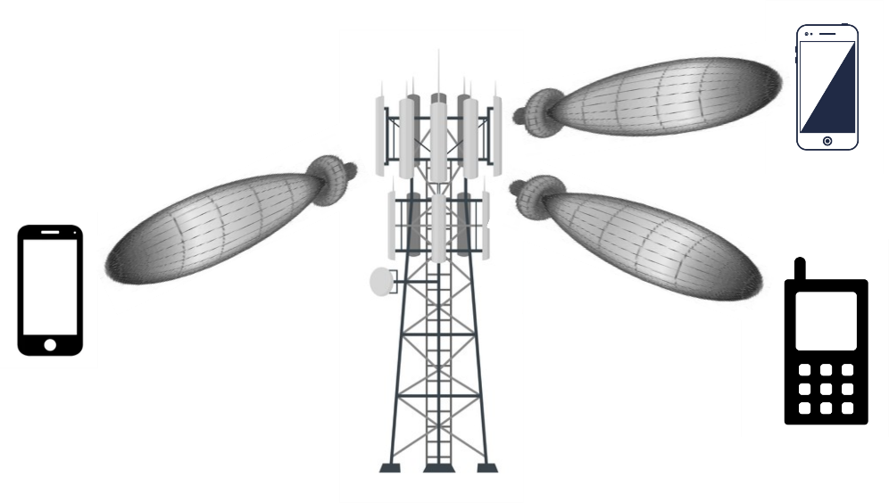

Figure 1. Beamforming technique.

On the other hand, the wide number of drone applications in agriculture, industry, transport, communication, surveillance, and environment and the development of IoT means that the use of related devices is increasing considerably [5]–[7]. However, drones can present a serious threat to civilian environments or sensitive areas such as airports and military bases. For example, in January 2015 a drone crashed at the White House [8], compromising the security of the government building. On March 29th, 2016, a Lufthansa jet came within 200 feet and collided with a drone near Los Angeles International Airport [9]. On October 12th, 2017, a Beech King Air A100 of Skyjet Aviation collided with a UAV as the former was approaching Jean Lesage Airport near Quebec City, Canada. The aircraft landed safely despite being hit on the wing [10].

Due to drones’ security risk facts, as discussed before, it is necessary to implement a drone DF system to confiscate or disable them. For the DF system, a signal from the drones is required to discover their directions. The drone’s owners do not want to be discoverable and they will not transmit such a signal that makes them vulnerable to a detection or DF system. Fortunately, most drones transmit a signal to communicate to their controllers to send images, video, and telemetry reports. Therefore, these signals are used by the DOA system to find the drone’s direction.

Due to the importance of the DOA estimation explained above, in this work, a new method is presented and analyzed to find the azimuth angle and elevation angle of a signal from a receiving system.

## RELATED WORK

With the aim of knowing the DOA of a coming signal, different studies have been carried out. In general, the DOA estimation techniques can be broadly classified into conventional beamforming techniques, Maximum Likelihood Estimator (MLE), and Subspace-Based Techniques (SBT). However, there are recent works on Received Signal Strength (RSS)-based DOA estimation [11]. Also, in recent years Machine Learning (ML) has been applied to these techniques. This section will give a brief summary of these techniques and their main works which introduces ML to obtain better results in DOA.

### Maximum Likelihood Estimation

The MLE finds its estimates by maximizing the probability density function at the observed received signals with respect to the model’s parameters. MLEs can be classified into two proposals: stochastic MLE and deterministic MLE. In the stochastic MLE [12]–[15], the signals are assumed to be Gaussian whereas they are regarded as arbitrary and deterministic in the deterministic ML method [14]–[17]. The sensor noise is modeled as Gaussian in both methods, which is a reasonable assumption due to the central limit theorem. The stochastic MLE of the bearings achieves the Cramer-Rao Bound (CRB). On the other hand, this does not hold for deterministic MLE.

In [13], the authors presented a method to derive a closed-form expression of the MSE of the DOA estimate based on the Taylor series expansion. In [14] A new deterministic MLE is derived. Its implementation is based on an iterative procedure that includes a stepwise concentration of the Log-Likelihood (LL) function with respect to the signal and noise nuisance parameters. In addition, new closed-form expressions for the deterministic and stochastic direction estimation CRBs are derived for the considered nonuniform model. In [18], is derived a deterministic MLE of multiple sources observed from the background of non-uniform white noise with an arbitrary diagonal covariance matrix. In [15], the performance of the MLE under conditions of low Signal-to-Noise Ratio (SNR) and a small number of array snapshots are investigated. In addition, a global error analysis is presented that can be used to predict the threshold behavior of the MLE with high accuracy. Both the deterministic and stochastic MLE are treated for the single-source and multisource estimation problems. In [17], the authors proposed a deterministic MLE for known waveform sources with different unknown time delays and Doppler shifts. Simulation results show that the proposed method can achieve a performance close to CRB at high SNR and with a large number of snapshots. In [19], a power-based maximum likelihood azimuth and elevation angle estimation scheme has been introduced on the basis of a suitable model for the Multi-Mode Antenna (MMA) presented in [20]. In [21], the authors proposed an MLE to joint azimuth, elevation, and Time Delay (TD) estimation of multiple reflections of a known signal. Additionally, the authors presented closed-form CRB for joint DOA and TD estimation.

The problem with MLEs is the high computational cost involved [22] since they have to solve a nonlinear multidimensional optimization problem and for which there is no guarantee of global convergence.

### Subspace-Based Techniques

### Sparse Signal Reconstruction

The SSR technique has been used in DOA estimation [23]–[30], which exploits the property that the spatial spectrum of the point source signals is sparse when the number of signals is limited. The key is to use appropriate non-quadratic regularizing functional (such a $l_{p}$-norms), which lead to sparsity constraints and super resolution.

In [23], is designed a weighted $l_{1}$-norm penalty whose weights correspond to the Capon spectrum in order to get a better approximation of $l_{0}$-norm and further enforce the sparsity. The authors in [24], proposed a SSR model based on the $l_{1}$-norm penalty in time domain after the Singular Value Decomposition (SVD) of the data matrix, converts the DOA estimation into a problem of SSR, and then solves it in a Second Order Cone (SOC) framework [25]. In [26], the authors treated the DOA target as a sparse vector in a discretized bearing space and apply $l_{1}$-norm minimization with the Dantzig selector [31] as a proxy of a combinatorial optimization problem to obtain multiple DOA of sources. The literature [27] proposes a weighted $l_{1}$-norm penalty using the property of noise subspace. These previous works, assume the ideal signal model regardless of unknown phase offset in $n$-th channel receiver, and at a particular time. Furthermore, its algorithms only aim to find the azimuthal angle of a source.

An $l_{1}$-SVD-like method under unknown MC for Uniform Linear Arrays (ULAs) has been proposed in [28], which takes advantage of the banded symmetric Toeplitz structure of MCM, but this method sacrifices the array aperture so that some array output data is not being used. In [29], the DOAs are obtained from a block sparse reconstruction framework with a block smoothed $l_{0}$-norm sparsity-promoting function, and it is solved by an iterative proximal algorithm. These works are only valid for ULA and only aim to find the azimuth angle. In [30], the algorithm of minimum $l_{1}$-norm reconstruction is used and the corresponding the CRB to the proposed estimation scheme is also derived. In addition, the major concern in SSR technique lies in the computational complexity.

### Machine Learning

ML is presented as a promising technology to be used for DOA. ML-based methods are data-driven and therefore they can be more robust than other methods due to they adapt better to array geometry imperfections and sensor imperfections. They also do not depend of the array geometry shape [32]. In addition, ML offers low-cost implementation and simplicity.

The authors in [33]–[37] used a Neuronal Network (NN) for DOA estimation. The authors in [33], proposed a DOA estimation method using a Complex-Valued Neural Network (CVNN) for ultra wideband systems. In [34] is used a Multilayer Perceptron Neuronal Network (MPNN) applied to the data received by a microphone array input. In [35] is used a Deep Neuronal Network (DNN) to DOA estimation and evaluate the estimation performance under a scenario where two equal-power and uncorrelated signals are incident on an ULA. The authors in [36], focused on scenarios where the number of active sources may exceed the number of simultaneously sampled antenna elements. For this purpose, they proposed new schemes based on NN and estimators that combine NNs with gradient steps on the likelihood function. In [37], the authors explored the problem of DOA estimation for two closely spaced sources. Their NNs comprise two parts, one for the SNR classification network and other for the DOA estimation network. In [38] the authors integrate a Multiple Input Multiple Output (MIMO) system with deep learning for channel estimation and find the DOA of a source. In this work, good results are obtained in the simulations, but they only focus on the azimuth angle and require a complex system (for example, the simulation scan was a MIMO system with 128 antennas). In [39] the authors propose a new DOA method based on an ML model to estimate the azimuth angle of a signal. The system employs only four antennas to find the direction of eight possible signal provenance angles. With this system was obtained a dataset named as *Dround Data New*, which contains well-known signals transmission powers for the eight angles. The authors trained and validated the dataset with a DNN model.

In [40]–[45], the authors proposed a Support Vector Regression (SVR) based DOA estimation. In [40], the use of a smart antenna system for the estimation of the DOAs of multiple waves is considered. In [41] the problem of estimating the DOAs of coherent electromagnetic waves impinging upon a ULA is considered, as an extension of the previous work, collecting experimental results. The authors in [43] proposed the combination of the advantages of Forward–Backward Linear Prediction (FBLP) and SVR in the estimation of DOAs of coherent incoming signals with low snapshots. In [44], the proposed solution consists of two stages: preprocessing and post-processing. Preprocessing takes advantage of the conjugate symmetry and Toeplitz property of the array covariance matrix to reduce the dimension of the input feature. The post-processing provides the directions of signals with different frequencies by exploiting the inherent relationship between direction and frequency. In [45], the authors proposed a scheme to address the wideband DOA estimation problem. An approach for the real-time DOA estimation of multiple signals impinging on a planar array is presented in [42]. In this last work, the azimuth and elevation angles of one or more incident sources in a ULA are found. However, there is still a lot of work to do on this issue since the angle resolution is still very low.

Table 1. Taxonomy of the proposed ML to DOA estimation.

|  |  |  |  |  |  |  |
| --- | --- | --- | --- | --- | --- | --- |
| reference | azimuth | elevation | single-source | multi-sources | narrowband | wideband |
| [32] |  | x |  | x | x |  |
| [33] |  | x |  | x |  | x |
| [34] | x |  | x |  | x |  |
| [35] |  | x |  | x | x |  |
| [36] | x |  |  | x | x |  |
| [37] | x |  |  | x | x |  |
| [38] | x |  | x |  | x |  |
| [39] | x |  | x |  | x |  |
| [40] |  | x | x | x | x |  |
| [41] |  | x | x | x | x |  |
| [42] | x | x | x | x | x |  |
| [43] |  | x |  | x | x |  |
| [44] |  | x |  | x | x |  |
| [45] | x |  | x |  |  | x |

To the knowledge of the authors, all ML-based DOA methods are of the supervised type. In supervised learning, the training data—called features or examples—that feed the ML algorithm include the desired solutions, called labels.

Based on the previous analysis, it can be concluded that overall ML techniques can offer better DOA methods than those mentioned above. ML has been used mainly to improve azimuth angle or elevation angle resolution and computing speed. In addition, various studies have been carried out to find the address of multiple sources. Figure 2 summarizes the DOA scenarios where ML techniques have been used. However, the study of the ML-based DOA complete response approach (knowledge of azimuth and elevation angle) has not been deeply studied. The reason behind this is the big size of the training data which is not supported by all models, like NN [46]. However, the estimation of both the elevation and the azimuth angles is crucial and has many applications in various fields of engineering. For instance, complete DOA information it is possible to improve the coverage of transmission in wireless communications by avoiding interferences and enhancing the system capacity [42]. More specifically, the knowledge of the azimuth and elevation angle would bring a better exploitation of the BF technology in the Next-Generation mobile networks.

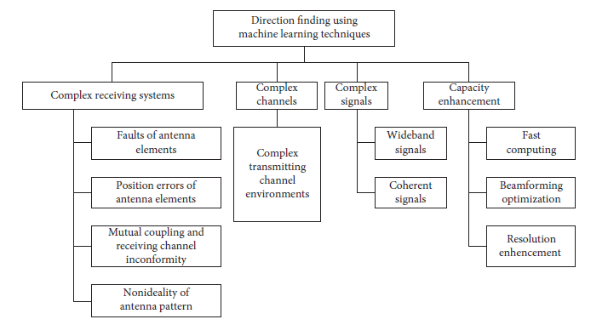

Figure 2. Overview of applications of ML in DOA [46].

## CLASSIFICATION MODEL

In this subsection a brief review of the ML model and the ensemble methods used in this work is given. This work uses the *Scikit-Learn* (*sklearn)* library [47] for ML models and their best performance.

### Support Vector Classification (SVC):

SVC tries to find the best hyperplane to separate different classes by maximizing the distance between sample points and the hyperplane. The SVC model [48] takes as input the following parameters:

* *kernel*: Selects the type of hyperplane used to separate the data. It must be one of linear, *poly*, *rbf*, *sigmoid*, *precomputed* or a callable.
* *C*: Is the penalty parameter of the error term. It controls the tradeoff between smooth decision boundary and classifying the training points correctly.
* *gamma*: Kernel coefficient for *rbf*, *poly* and *sigmoid*.

### Decision Trees (DT):

DT models are one of the simplest and yet most successful forms of ML models [49]. The goal of DT is to create a model that predicts the value of a target variable by learning simple rules inferred from the data features. The DT models build a tree during training that is the one applied when making the prediction. The input and output values can be discrete or continues. The *DecisionTreeClassifier* class, from the *Scikit-Learn* (*sklearn)* library, supports multi-output problems [50] and; therefore, this model can be used in the two proposals explained in the last section. In this work, the *DecisionTreeClassifier* class takes as input the following parameters:

* *max_depth*: This indicates how deep the tree can be.

### Extra Decision Trees (EDT):

Extra-trees differ from classic decision trees in the way they are built. *ExtraTreeClassifier* [51] is a randomized version of *DecisionTreeClassifier* meant to be used internally as part of ensemble methods. The parameters that we take into account in the model are the same as in DT.

### Bagging Classifier (BC)

It is an ensemble meta-estimator that fits base classifiers each on random subsets of the original dataset and then aggregates their individual predictions (either by voting or by averaging) to form a final prediction [52]. In this work, the BC takes as input the following parameters:

* *base_estimator*: Applied to random subsets of the dataset. The base classifier used was DT.
* *n_estimators*: The number of base estimators (in this case, the number of DT) in the ensemble.
* *max _samples*: The number of samples to extract from the training data to train each base estimator.
* *bootstrap*: Parameter which defines whether samples are drawn with replacement. If *False*, sampling without replacement is performed.
* *n_jobs*: Tells *Scikit-Learn* the number of CPU cores to use for training and prediction. *n_jobs* is *None* by default, which means unset; it will generally be interpreted as *n jobs* = 1 which means that only one core will be used by *Scikit-Learn*. *n_jobs* = -1 tells *Scikit-Learn* library to use all available cores. For *n_jobs* below -1, number of cores + 1 + *n_jobs* are used. For example, with *n_jobs* = -2, all CPUs but one is used.
* *random_state*: Provided to control the random number generator used. The values of random state can be: *None* (default), an integer, and a *numpy.random*.*RandomState* instance. *random state*= *None* calls the function multiple times, it will reuse the same instance, and it will produce different results. If *random_state* is an integer, it is going to use a new random number generator seeded by the given integer. Using an integer will produce the same results across different calls. Popular integer random seeds are 0 and 42. The *numpy.random.RandomState* instance uses the provided random state, only affecting other users of that same random state instance.

## RESEARCH PROBLEM

The non-existence of a DOA method, with a simple system that detects both the azimuth angle and the elevation angle, how is capable of responding to the needs of the next mobile communication networks and their main technologies such as BF.

## HYPOTHESIS

If we obtain the powers of the signal transmitted by a device in each of the antennas of a receiving system made up of $M$ circularly distributed antennas and relate each of the powers, we can deduce the angle of azimuth and elevation formed between the transmitter and the center of the receiving system through a machine learning model of supervised learning classification.

## OBJECTIVES

The main goal of this work is to propose an ML model to find the azimuth angle and the elevation angle of a signal coming from an antenna. To achieve the latter, the following specific objectives are considered:

* Design an antenna system receptor to find the DOA.
* Discuss training data preparation and designing for a specific scenario.
* Analyze different proposals to find both angles with ML models.
* Analyze different ML models.
* Select the best proposal to find the azimuth angle and elevation angle as well as the ML model from simulation results.
* Compare the results obtained in this paper with DOA models presented in the literature previously.

# CHAPTER 2: SIGNAL AND SYSTEM MODEL

## SYSTEM MODEL

We consider a system that consists of a single channel receiver, and $M$ directional antennas uniformly positioned forming a circle with a radius $r$. The antennas are connected to the receiver using a non-reflective Single-Pole-M-Throw (SPMT) Radio Frequency (RF) switch, see Figure 3. The switching period is $T_{s}$. If a signal impinges on the center of the circle formed by the $M$ antennas with azimuth ($ϕ$) and elevation angles ($θ$) as shown in Figure 4, the received signal at the $m$-th antenna element can be given as:

|  |  |  |
| --- | --- | --- |
|  | $$r_{m}\left(k\right)=a_{m}\left(δ_{m}, β_{m}\right)s\left(k\right)+ n_{m}\left(k\right),$$ | Eq. 1 |

where $k$ is the sample index, $s\left(k\right)$ is the signal transmitted by the source as it arrives at the antenna array, $n_{m}\left(k\right)$ is circularly symmetric, independent and identically distributed, complex Additive White Gaussian Noise (AWGN) with zero mean and variance $σ^{2}$, and $m$ $∈$ {1, …, $M$}. $a_{m}(δ_{m}, β_{m})$ represents the attenuation factor (phase shift and amplitude attenuation) and the $m$-th antenna response vector for the azimuth angle $δ_{m}∈ [0:2π)$ and elevation angle $β_{m}∈ [0:\frac{π}{2})$, which depends on the characteristics of the antenna element, its position relative to the origin of the coordinate system, and its response to a planar wave coming from the direction of the $δ_{m}, β_{m}$ signal, see Figure 4.

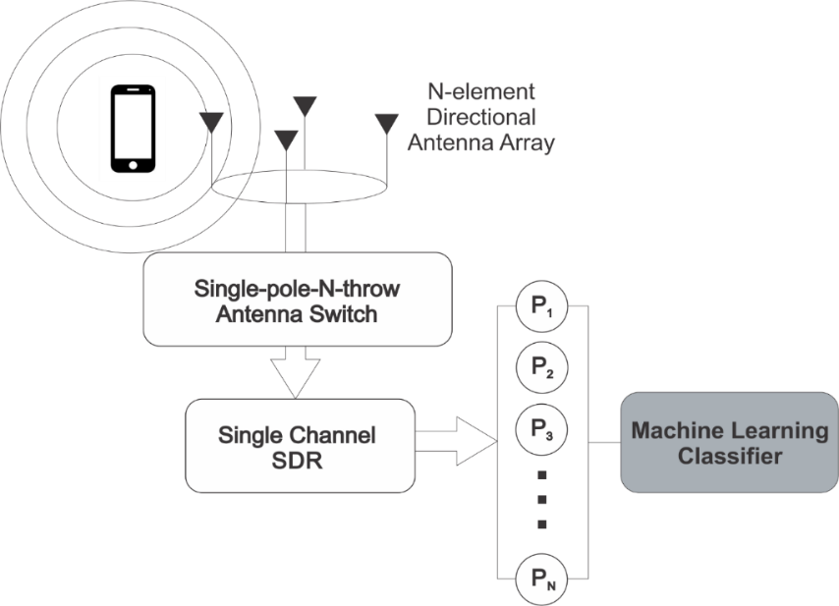

Figure 3. The System Model.

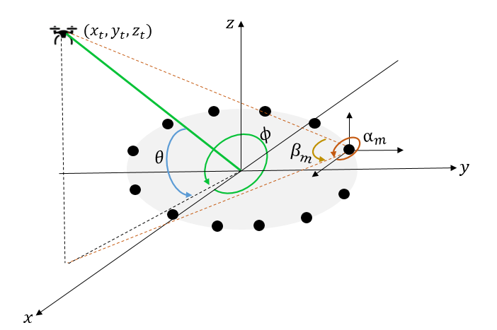

Figure 4.

This work employs the power received by each of the receiving antennas in the system to estimate the azimuth and elevation angles. Then the resulting power received at each of the antennas is given by:

|  |  |  |
| --- | --- | --- |
|  |  | Eq. 2 |

$P_{m}$ can be approximated through the sample mean so:

|  |  |  |
| --- | --- | --- |
|  |  | Eq. 3 |
|  | $$\hat{P_{m}}=E\left[{\left(a_{m}\left(δ_{m}, β_{m}\right)s\left(k\right)+ n_{m}\left(k\right)\right)\left(a_{m}\left(δ_{m}, β_{m}\right)s\left(k\right)+ n_{m}\left(k\right)\right)}^{*}\right].$$ | Eq. 4 |

Following the fact that $s$ and $n$ are independent and uncorrelated, thus

|  |  |  |
| --- | --- | --- |
|  |  | Eq. 5 |
|  | $$P_{m}=G_{m}^{2}\left(δ_{m}, β_{m}\right)P_{s}+σ^{2},$$ | Eq. 6 |

where:

|  |  |  |
| --- | --- | --- |
|  |  | Eq. 7 |
|  |  | Eq. 8 |
|  |  | Eq. 9 |

Our goal is to estimate the azimuth $ϕ$ and elevation $θ$, angles from the array received powers while the parameters $s\left(k\right)$ and $a_{m}\left(δ_{m}, β_{m}\right)$ are unknown.

## PROPOSED METHOD

The proposed method is described next. The receiver sequentially activates one antenna element at a time using the SPMT RF switch, collects $K$ samples, and calculates the corresponding average received power ($\hat{P_{m}}$) value for that element. During the activation of the $m$-th antenna, $\hat{P_{m}}$ is measured. A single switching cycle is equivalent to $M$ activations, starting from the first antenna up to the $M$-th one. Let $p=\left[\hat{P_{1}},…,\hat{P_{M}}\right]$ denote the power measurements corresponding to a single switching cycle.

The pre-processing of the data is an essential step to achieving good classification performance before evaluating the data on the machine learning algorithms. Data normalization is an essential pre-processing step that involves the transformation of features in a common range so that greater numeric feature values cannot dominate the smaller numeric feature values [53]. Therefore, the ratio between $\hat{P_{m}}$ and the summation of all average power values within the same switching cycle is given as

|  |  |  |
| --- | --- | --- |
|  | $$x_{m}=\frac{\hat{P_{m}}}{\sum_{l=1}^{M}{\hat{P_{l}}}}.$$ | Eq. 10 |

Let $x=\left[x_{1},…,x_{M}\right]$ denote the normalized average power measurements vectors corresponding to a single switching cycle over all antenna elements. In the next section, it is discussed how to recover $ϕ and θ$ from $x$ when ML models are employed.

## DOA ESTIMATION AS A CLASSIFICATION PROBLEM

This work uses supervised learning to find $ϕ and θ$ angles. In supervised learning, the training data feed to the algorithm includes pairs of fixed dimension feature vectors and the desired solutions, called labels. If the size of the dataset is $L$, the fixed-dimensional feature vectors are $x_{1}, x_{2}, …x_{L},$ and the labels are their respective azimuth and elevation angles that form between the transmitter and the center of the receiving system ($ϕ_{1}, ϕ_{2}, …ϕ_{L} and θ_{1}, θ_{2}, …θ_{L}$), where $ϕ_{1}, ϕ_{2}, …ϕ_{L}$ are values between $0$ and $2π$ angle and $θ_{1}, θ_{2}, …θ_{L}$ are values between $0$ and $\frac{π}{2}$.

Two proposals are considered to estimate $ϕ and θ$ angles from the average received power vector ($x$) where both of them are formulated as a multiclass classification problem *—*In the literature, this type of classification problem is denoted as $I$-class, where $I$ is the number of classes*—* The two proposals are:

* Separated Proposal (SP): Find the azimuth and the elevation angles independently. Here, the problem of DOA estimation is divided into two independent classification problems: One to find the azimuth angle and another to find the elevation angle.
* Multi-Output Multi-Label Proposal (MMP): Find the azimuth and the elevation angles with a multi-label and multi-output ML model.

### Separated Proposal

In the first proposal, there are two independent models to calculate the azimuth and the elevation angles respectively. In this proposal, each class corresponds to a possible DOA value in the set $ϕ = \{ϕ_{1},. . . , ϕ_{N}\}$ for the azimuth angle and $θ= \left\{θ_{1},…,θ_{P}\right\}$ for the elevation angle. $N$ and $P$ are the largest angle of azimuth and elevation respectively. The number of classes, $I$, depends on the resolution for the discretization of the whole range of DOAs. Then the number of classes of the models to find the $ϕ and θ$ angles, respectively, are given by

|  |  |  |
| --- | --- | --- |
|  | $$I_{SP-ϕ}=\frac{int\left[\left(ϕ_{N}-ϕ_{1}\right)\right]}{resolution},$$ | Eq. 11 |
|  | $$I_{SP-θ}=\frac{int\left[\left(θ_{N}-θ_{1}\right)\right]}{resolution},$$ | Eq. 12 |

where the $int[]$ operator represents the integer conversion. For example, if the ranges azimuth and the elevation angles lie between [$0^{°}$, ${360}^{°}$] and [$0^{°}$, ${90}^{°}$] respectively, and both models have a resolution of $1^{°}$, the number of classes is equal to $I_{SP-ϕ}$ = 360 and $I_{SP-θ}$ = 90, respectively.

### Multi-Output Multi-Label Proposal

The last proposal is set as a multi-output and multi-label classification problem. That means each sample for the training of the model will have multiple labels ( $ϕ$ and $θ$) and that the trained model will output more than one value, i.e., $ϕ$ and $θ$ in this case. The number of classes the model has to determine is equal to the number of the azimuth angle classes plus the number of the elevation angle classes divided by the resolution, as shown in Equation (13).

|  |  |  |
| --- | --- | --- |
|  | $$I_{MMP}=\frac{int\left[\left(ϕ_{N}-ϕ_{1}\right)\right]+int\left[\left(θ_{P}-θ_{1}\right)\right]}{resolution}.$$ | Eq. 13 |

## METRICS AND SCORING

### The performance metrics used in this work to compare the proposals explained above and the ML models are accuracy and Mean Square Error (MSE). Accuracy is the fraction of output values that are correctly predicted by ML model, i.e., the fraction of outputs matching the labels. The MSE of an estimator measures the average of the squares of the errors—that is, the average of the squared difference between the estimated values and the actual ones.

### Separated proposal

If ${\hat{y}}_{i}$ and ${\hat{z}}_{i}$ are the predicted values for the $i$ -th input sample and $y_{i}$ and $z_{i}$ are the corresponding true values, then the fraction of correct predictions of models estimating azimuth and elevation angles, over $L$ samples, is defined as

|  |  |  |
| --- | --- | --- |
|  | $${accuracy}_{SP-ϕ}\left(y,\hat{y}\right)=\frac{1}{L}\sum_{i=0}^{L-1}{1({\hat{y}}_{i}=y_{i})}$$ | Eq. 14 |
|  | $${accuracy}_{SP-θ}\left(z,\hat{z}\right)=\frac{1}{L}\sum_{i=0}^{L-1}{1({\hat{z}}_{i}=z_{i})}$$ | Eq. 15 |

where $1(x)$ is an indicator function that is one if the values being compared are equal and zero otherwise. The expressions used to calculate the MSE of the predictions of azimuth and elevation angles, over $L$ samples, are defined as

|  |  |  |
| --- | --- | --- |
|  | $${MSE}_{SP-ϕ}\left(y,\hat{y}\right)=\frac{1}{L}\sum_{i=0}^{L-1}{{({\hat{y}}_{i}-y_{i})}^{2}}$$ | Eq. 16 |
|  | $${MSE}_{SP-θ}\left(z,\hat{z}\right)=\frac{1}{L}\sum_{i=0}^{L-1}{{({\hat{z}}_{i}-z_{i})}^{2}}$$ | Eq. 17 |

Being independent events, the accuracy of the SP is given by:

|  |  |  |
| --- | --- | --- |
|  | $${accuracy}_{SP}={{accuracy}_{SP-ϕ}*accuracy}_{SP-θ}$$ | Eq. 18 |

and the MSE is given by:

|  |  |  |
| --- | --- | --- |
|  | $${MSE}_{SP}={{MSE}_{SP-ϕ}+MSE}_{SP-θ}$$ | Eq. 19 |

### Multi-Output Multi-Label Proposal

In this case, the expressions for calculating accuracy and MSE are given, respectively, by

|  |  |  |
| --- | --- | --- |
|  | $${accuracy}_{MPP}\left(y,\hat{y},z,\hat{z}\right)=\frac{1}{L}\sum_{i=0}^{L-1}{1({\hat{y}}_{i}=y_{i} and {\hat{z}}_{i}=z_{i})}$$ | Eq. 20 |
|  | $${MSE}_{MPP}\left(y,\hat{y},z,\hat{z}\right)=\frac{1}{L}\sum_{i=0}^{L-1}{{({\hat{y}}_{i}-y_{i})}^{2}+}{({\hat{z}}_{i}-z_{i})}^{2}$$ | Eq. 21 |

## PARTIAL CONCLUSIONS

This chapter explained the system model, which consists of $M$ antennas uniformly spaced, forming a circle. A switch connects to each of the antennas at a time for collecting $K$ samples used to calculate the average received power. The power received at each antenna from a transmitter feeds an ML model that predicts the azimuth and elevation angles of the transmitter in relation to the center of the antenna array. There are two kinds of proposals for the training of the ML models: (i) the separated proposal where azimuth and elevation angles are independently predicted, and (ii) the multi-label proposal where both angles are simultaneously predicted.

# CHAPTER 3: IMPLEMENTATION OF THE SIMULATION SCENARIO

This chapter describes the simulation scenario used to generate the training data that will be used in later chapters for the presentation and analysis of our proposal. As mentioned in the previous chapter, the normalized average power measurement vectors and their respective azimuth and elevation angles at a distance of $p$ meters from the center of the coordinate system, as shown in Figure 3, form the dataset. Figure 4 implements the flowchart to simulate the average received power at each of the antennas ($\hat{P_{m}})$.

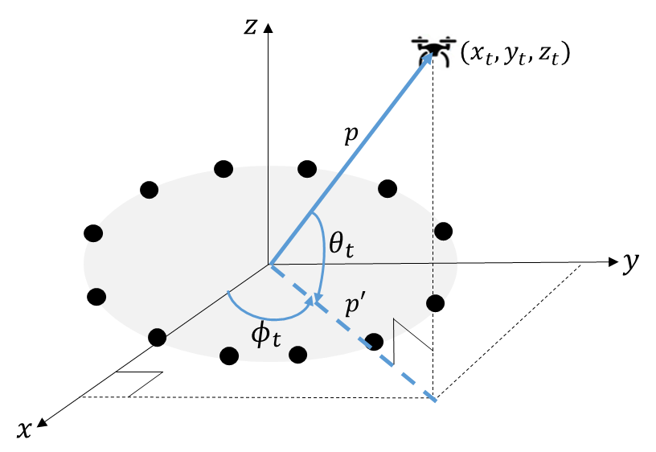

Figure 3. Coordinates of the transmitter with respect to the center of the antenna array.

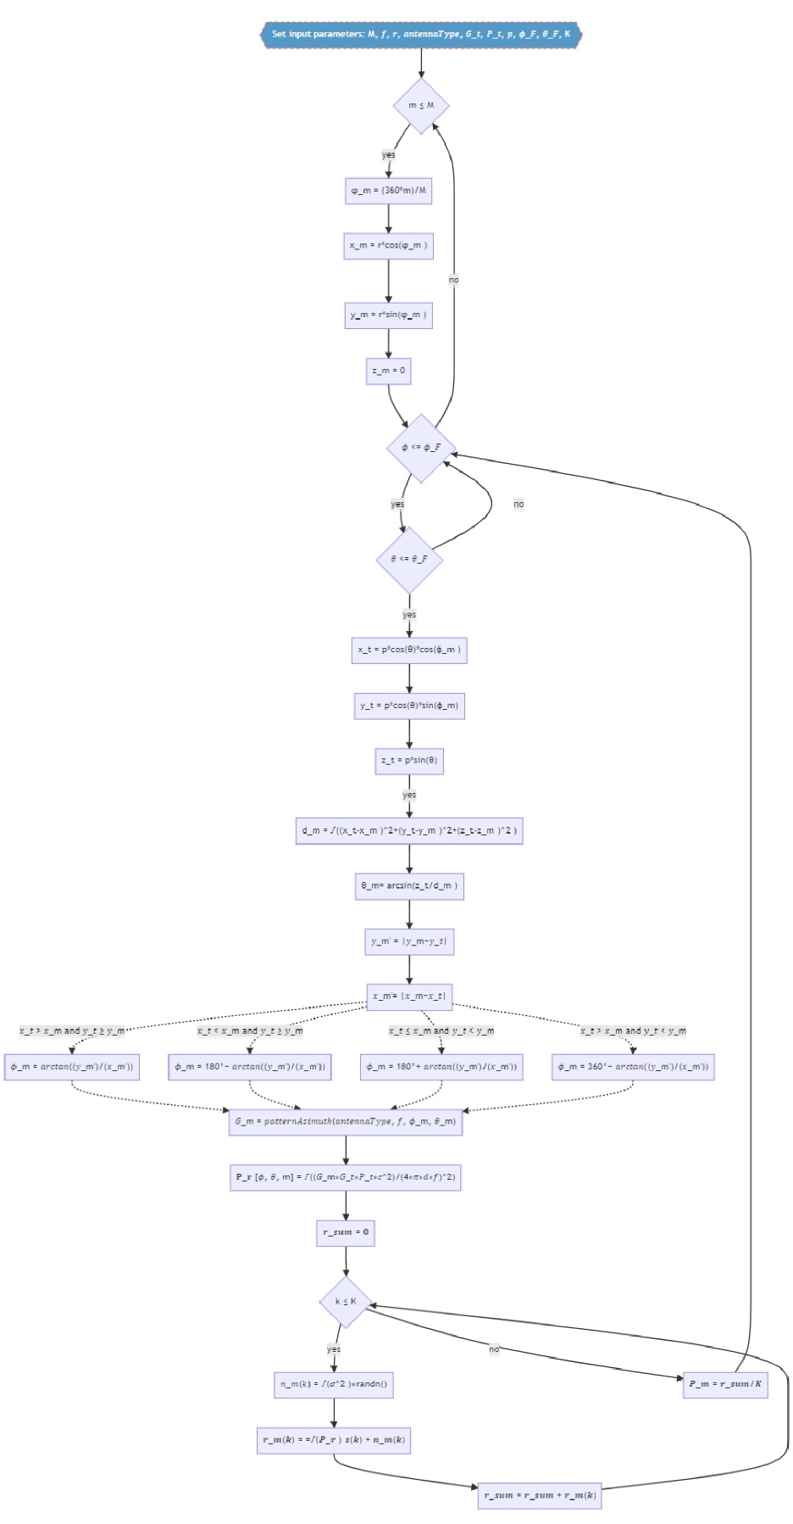

Power received

Angles

Distance

Transmitter coordinates

Antennas coordinates

Figure 5. Flowchart of the implementation of the scenario.

## COORDINATES OF THE ANTENNAS

We consider a Cartesian coordinate system with orthogonal unit directions ($\hat{x},\hat{y},\hat{z}$) as a reference coordinate system. $M$ directional antennas are uniformly positioned forming a circumference on the $xy$ plane. The first antenna is placed upon the $x$ axis (see Figure 5). Each antenna has coordinates $\left(x_{m}, y_{m},0\right)$, and the very first antenna has coordinates $\left(x_{1},0, 0\right)$. As the $M$ antennas are uniformly positioned on a circle of radius $r$, then, each antenna is $\frac{360}{M}$ degrees apart from each other. Therefore, the displacement of the *m*-th antenna with respect to an adjacent antenna can be expressed as

|  |  |  |
| --- | --- | --- |
|  | $$φ_{m}=\frac{360*m}{M}.$$ | .Eq. 22 |

The radius of the circumference formed by the antennas is denoted by $r$. Then the coordinates of the antennas are given by

|  |  |  |
| --- | --- | --- |
|  | $$x_{m}=r*cos\left(φ_{m}\right)$$ | Eq. 23 |
|  | $$y_{m}=r*sin\left(φ_{m}\right)$$ | Eq. 24 |
|  | $$z_{m}=0$$ | Eq. 25 |

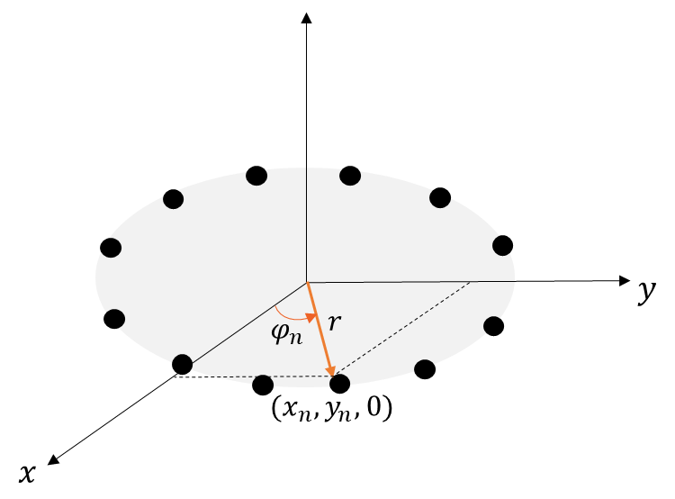

Figure 6. Coordinates of the antennas.

## TRANSMITTER COORDINATES

A transmitter at a distance $p$, which forms an azimuth angle $ϕ$ and an elevation angle $θ$ with the center of the coordinate axis, as shown in Figure 3, has the following coordinates:

|  |  |  |
| --- | --- | --- |
|  | $$x_{t}=p'*cos\left(ϕ\right)$$ | Eq. 26 |
|  | $$y_{t}=p'*sin\left(ϕ\right)$$ | Eq. 27 |
|  | $$z_{t}=p*sin\left(θ\right)$$ | Eq. 28 |

where $p'$ is the projection of the vector $p$ on the $xy$ plane and is given by

|  |  |  |
| --- | --- | --- |
|  | $$p^{'}=p*cos\left(θ\right)$$ | Eq. 29 |

Then the transmitter coordinates, Equations (26), and (27) can be rewritten as

|  |  |  |
| --- | --- | --- |
|  | $$x_{t}=p*cos\left(θ\right)*cos\left(ϕ\right)$$ | Eq. 30 |
|  | $$y_{t}=p*cos\left(θ\right)*sin\left(ϕ\right)$$ | Eq. 31 |

## DISTANCE BETWEEN TRANSMITTING ANTENNA AND RECEIVING ANTENNAS

With the transmitting and receiving antennas coordinates, it is possible to calculate the distance between them by employing the formula of the distance between two points in a cartesian coordinate system (see Figure 6)

|  |  |  |
| --- | --- | --- |
|  | $$d_{m}=\sqrt{{\left(x_{t}-x_{m}\right)}^{2}+{\left(y_{t}-y_{m}\right)}^{2}+{\left(z_{t}-z_{m}\right)}^{2}},$$ | Eq. 32 |

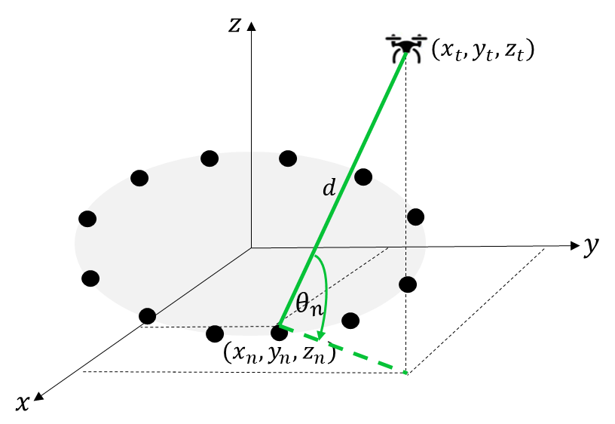

Figure 7. Distance between the transmitting antenna and the m-th receiving antenna.

## ANGLES BETWEEN TRANSMITTING ANTENNA AND RECEIVING ANTENNAS

The angle, $θ_{m}$, between the *m*-th receiving antenna and the source (i.e, the transmitter) on the $yz$ plane is shown in Figure 6 and is calculated as

|  |  |  |
| --- | --- | --- |
|  | $$θ_{m}= arcsin\left(\frac{z_{t}}{d_{m}}\right)$$ | Eq. 33 |

The formula to calculate the angle between the *m*-th receiving antenna and transmitter on the $xy$ plane ($ϕ_{m}$) depends on the position of both of them in the coordinate system, as shown in Figure 7.

|  |  |  |
| --- | --- | --- |
|  | $$ϕ_{m}= \left\{\begin{aligned} arctan\left(\frac{y_{m}^{'}}{x_{m}^{'}}\right), x_{t}>x_{m} and y_{t}≥y_{m} \\ {180}^{0}-arctan\left(\frac{y_{m}^{'}}{x_{m}^{'}}\right), x_{t}<x_{m} and y_{t}≥y_{m} \\ {180}^{0}+arctan\left(\frac{y_{m}^{'}}{x_{m}^{'}}\right), x_{t}≤x_{m} and y_{t}<y_{m} \\ {360}^{0}-arctan\left(\frac{y_{m}^{'}}{x_{m}^{'}}\right), x_{t}>x_{m} and y_{t}<y_{m}. \\ \end{aligned}\right.$$ | Eq. 34 |

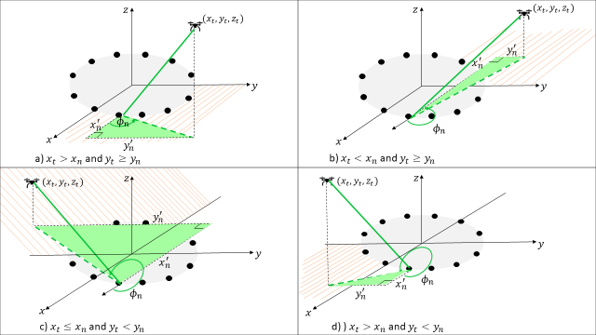

Figure 8. Angle between the receiving antenna and transmitter antenna in the $xy$ plane.

## POWER RECEIVED ON EACH OF THE RECEIVING ANTENNAS IN THE SYSTEM

From Equation (1), the noise term can be re-expressed as

|  |  |  |
| --- | --- | --- |
|  | $$n_{m}\left(k\right)= \sqrt{σ^{2}}*randn()+ μ$$ | Eq. 35 |

where $σ^{2}$, $randn()$, and $μ$ are the noise variance, a random value picked up from the standard normal distribution, and the noise mean, respectively. Then, the signal model can be written as:

|  |  |  |
| --- | --- | --- |
|  | $$r_{m}\left(k\right)=a_{m}\left(δ_{m}, β_{m}\right)*s\left(k\right)+ \sqrt{σ^{2}}*randn()+ μ,$$ | Eq. 36 |

where:

|  |  |  |
| --- | --- | --- |
|  | $$a_{m}\left(δ_{m}, β_{m}\right)= \frac{λ}{4πd}\sqrt{G_{T_{x}}G_{m}(δ_{m}, β_{m})}*\sqrt{P_{s}},$$ | Eq. 37 |

which is computed from the Friis formula by transforming the antenna gains and transmitter power into voltages by applying the square operator [54]. Then, substituting Equation (37) into Equation (36), the received power on each of the receiving antennas is given by

|  |  |  |
| --- | --- | --- |
|  |  | Eq. 38 |

## PARTIAL CONCLUSIONS

For the simulations, a 3D coordinate system is used, where the (0, 0, 0) point represents the center of the circular antenna array with the receiving antennas placed along the circumference with an equidistant separation. A transmitter is placed at a random point of the space and then the distance, the azimuth and elevation angles related to each antenna are computed. With these values, it is possible to compute the gain of every receiving antenna in the direction of the transmitter. Finally, the average receiving power at each antenna is computed with a signal model perspective using the Friis formula and applying power to voltage conversion.

# CHAPTER 4: RECEIVER SYSTEM DESIGN

The main objective of this chapter is to analyze different models of receiver systems, i.e., antenna arrays, to measure the transmitter power and assess the impact of the position, number, and type of the antennas on the performance of a ML model used for angle prediction. The comparison is carried out based on the results obtained with ML models for the samples taken with such receiving systems. Finally, based on the results obtained with the simulations, a receiver model system is proposed.

## DATA GENERATION

This chapter analyzes the impact of the above mentioned parameters on the performance of a DT model with data taken by the receiving systems shown in Figures 8 and 9. The first receiver model consists of four antennas (*M=4*) placed on the ground and uniformly distributed, forming a circle. The radius, $r,$ of the circle is equal to half of the wavelength, i.e., $r= λ/2$. In the second receiving system, an extra antenna is added at a height of $r$ at the center of the circle formed by the antennas (*M=5*). Therefore, the one extra antenna is added to the receiving system with the following Cartesian coordinates

|  |  |  |
| --- | --- | --- |
|  | $$x_{m+1}=0$$ | Eq. 38 |
|  | $$y_{m+1}=0$$ | Eq. 39 |
|  | $$z_{m}=r$$ | Eq. 40 |

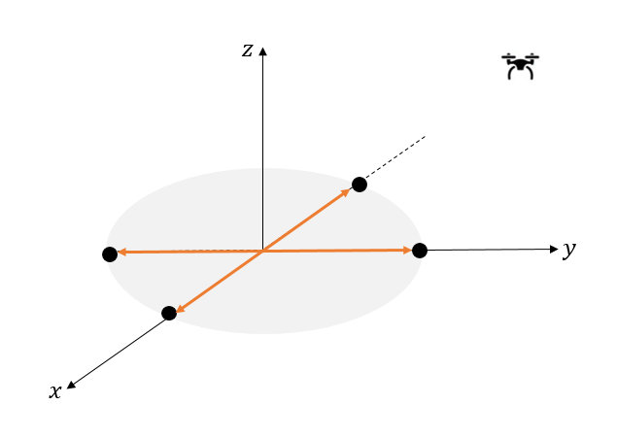

Figure 9. First receiver model proposal.

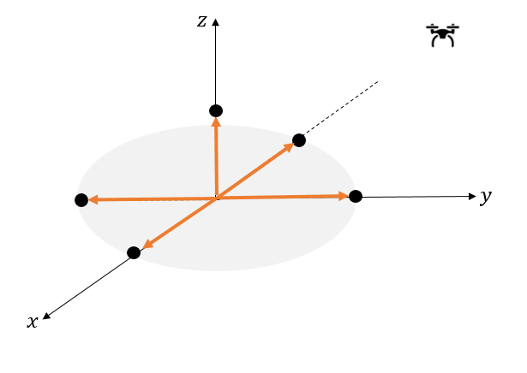

Figure 10. Second receiver model proposal.

Both systems are compared with strip and planar V-dipoles as the receiving antennas (also known as Vee-dipoles), operating at a frequency of 70 MHz. The antennas’ radiation patterns are shown in Figures 11 and 12, respectively. Therefore, the results of the DT model are analyzed with the data provided by the following four receiving models:

* First Receiver Model: Consists of four strip dipole antennas.
* Second Receiver Model: Consists of five strip dipole antennas.
* Third Receiver Model: Consists of four planar V-dipole antennas.
* Fourth Receiver Model: Consists of five planar V-dipole antennas.

To collect the data samples, it uses the method described in Chapter 3 to simulate the power arriving at the antennas from different directions. It means, for each pair of azimuth and elevation angles, i.e., $(ϕ_{i},θ_{j})$, the corresponding average receiving power at each antenna ($m$) was obtained. Azimuth and elevation angles are in the range [$0^{0},{ 360}^{0}$) and [$0^{0},{ 90}^{0}$), respectively, with an angle resolution of $1^{0}$. For each angle pair, $samples$ = 15 normalized average power measurement vectors were generated. This way, the number of normalized average power measurement vectors generated is equal to 486,000 (${samples×\left(ϕ_{M}-ϕ_{1}\right)×\left(θ_{P}-θ_{1}\right)}/{resolution}$) for each receiving antenna. It is assumed that $s\left(k\right)=1,∀k$ and $n_{m}\left(k\right)$ is circularly symmetric, independent and identically distributed complex Additive White Gaussian Noise (AWGN) with zero mean and variance equal to ${10}^{-10}$.

All receiving models are simulated in Matlab for the dataset generation, then, they are used to train the ML model, which is performed on an Acer laptop with a Core i7 processor, 16 GB RAM, and a 8 GB Intel(R) Iris(R) Xe Graphics video card.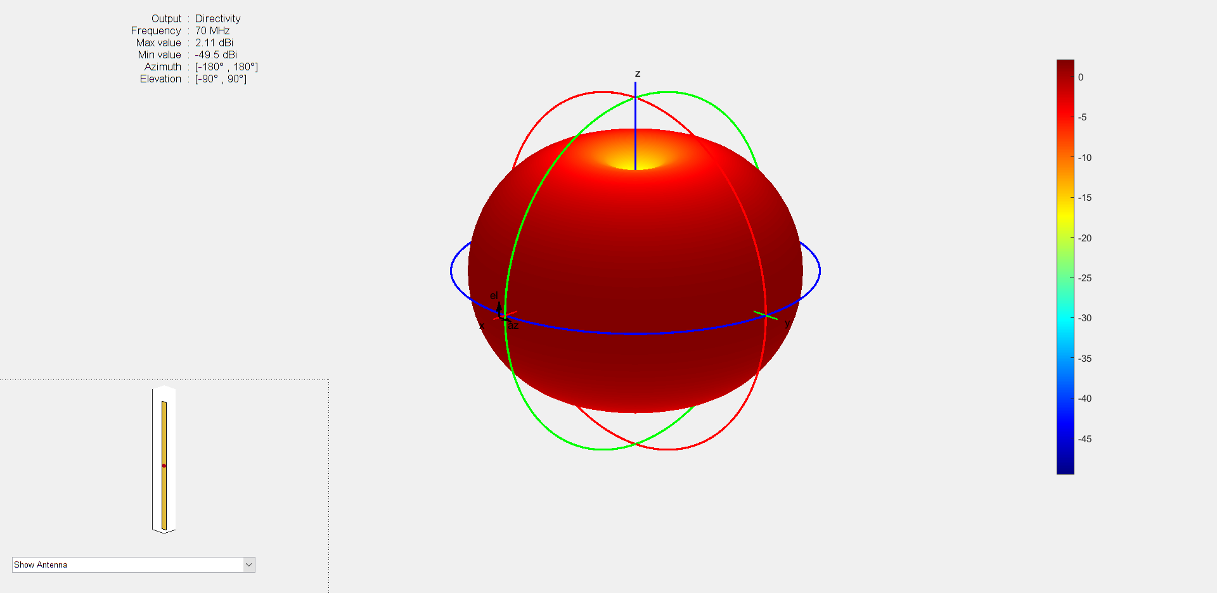

Figure 11. Radiation pattern of the strip dipole antenna operating at 70 MHz.

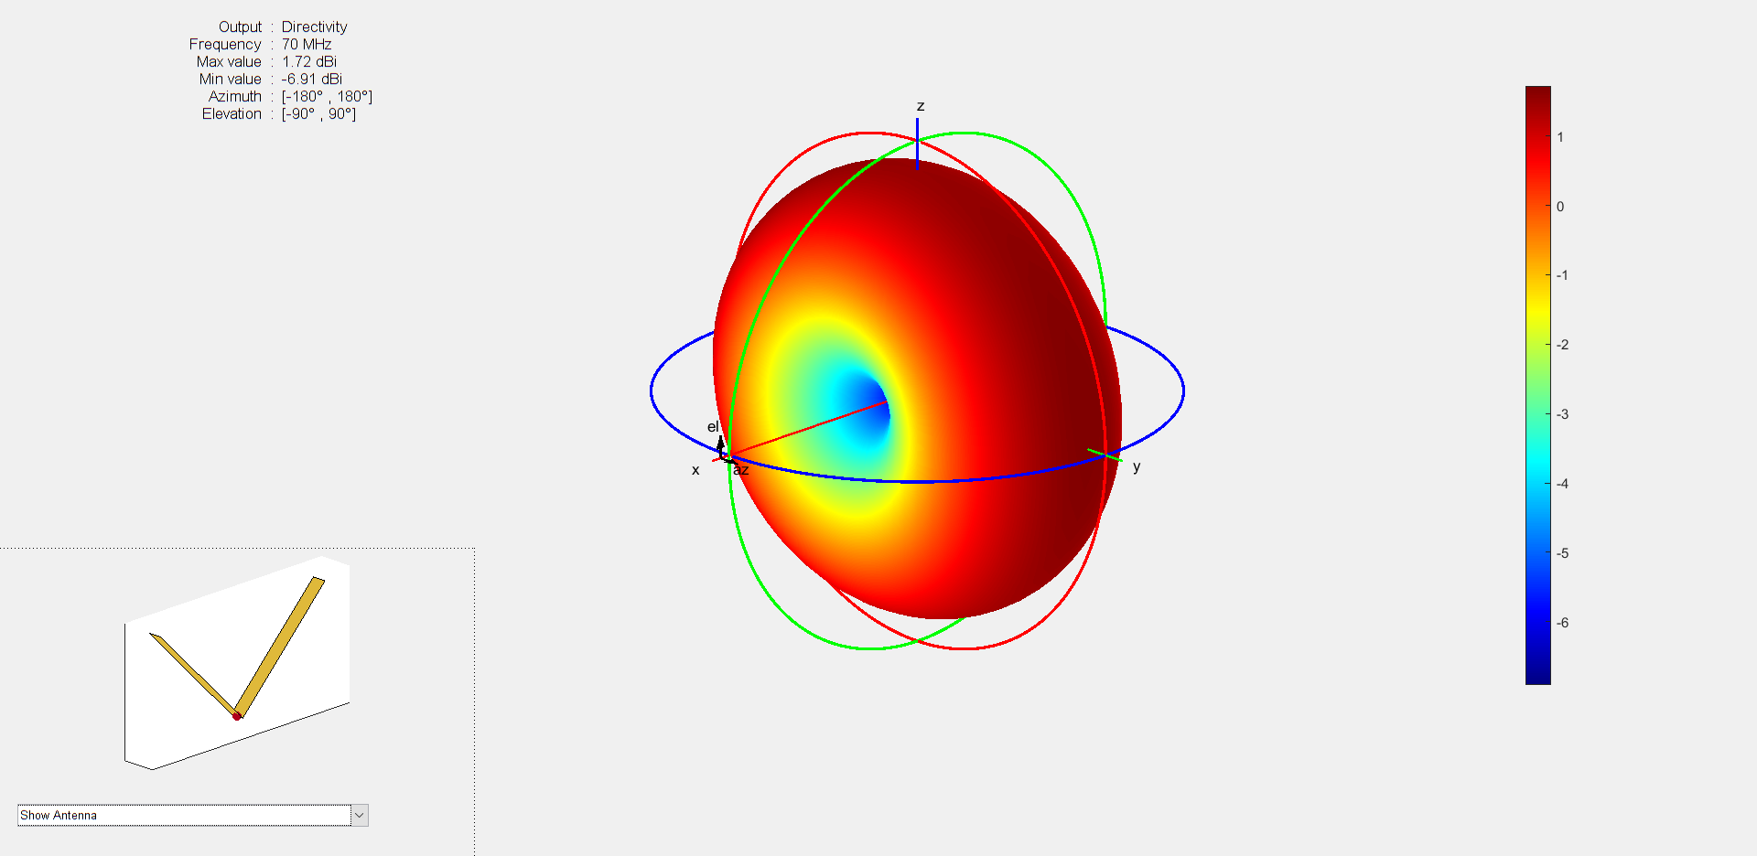

Figure 12. Radiation pattern of the planar V-dipole antenna operating at 70 MHz.

## ANALYSIS OF AZIMUTH ANGLES FOR THE FIRST RECEIVER SYSTEM MODEL

Figure 12 shows the confusion matrix for the azimuth angles of the DT model trained with the data provided by the first receiving system. From this figure, it can be seen that the model is confusing the actual azimuth angles with the actual angles plus 180°. For example, angles from 5° to 9° are confused with angles from 185° to 189°, and angles from 225° to 229° are confused with angles from 45° to 49°, respectively. Figure 13 shows which elevation angles the model is confusing by finding the azimuth angles. The model makes the greatest number of azimuth angle prediction errors for elevation values ​​between 40° and 70°, approximately. This is due to the effects that noise and the radiation pattern of dipole antennas have on the received powers. Table 2 compares the powers measured for some elevation angles between 40° and 70° with the first system and the powers with an ideal system. The table shows that not because a receiving antenna is closer to the transmitter, it will be the one that measures the highest receiving power and that the DT model is not learning. For example, for the first row shown in Table 2 (see Figure 14), where the actual azimuth and elevation angles are equal to 8° and 53°, respectively, the highest received power is $P_{3}$ and the lowest is $P_{1}$ for the system with and without noise. These are the powers measured at the antennas farthest and closest from the source, respectively. This is due to the radiation pattern of the strip dipole antennas (see Figure 15). Then the DT model interprets that the closest antenna to the source is $M_{3}$ and with that information and that of the rest of the antennas, it predicts that the azimuth angle is 187° instead of 8°. This is an effect that will be more accentuated for elevation angles around 45°, as shown in Figure 13. As the noise in the system decreases, the pattern tends to disappear. As the noise increases, too many errors are generated for all angles and not just when the transmitter is around an elevation of 45° from the center of the receiving system. Appendix A shows the confusion matrices of the azimuth angles for the first receiving system with a noise of zero mean and variances of ${ 10}^{-7}$, ${ 10}^{-8}$, ${ 10}^{-9}$, ${ 10}^{-11}$, and ${ 10}^{-12}$, respectively, where the latter is corroborated.

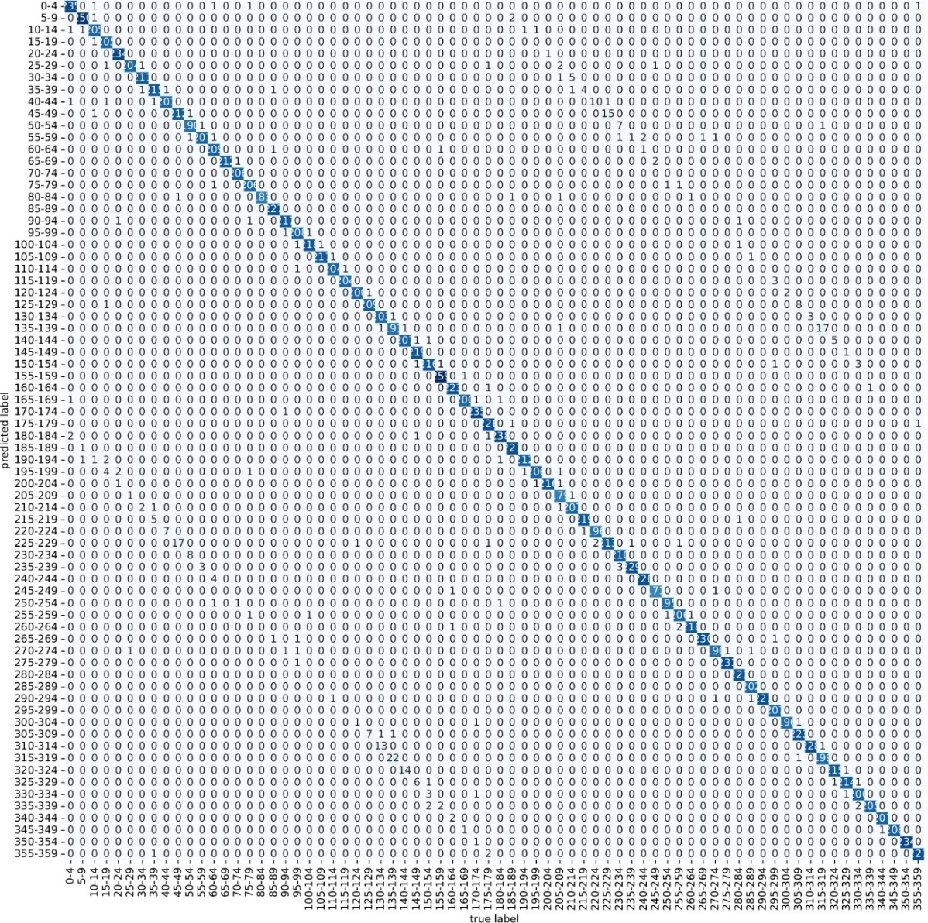

Figure 13. Confusion matrix for the azimuth angles predicted by the DT model trained with the data provided by the first receiving system.

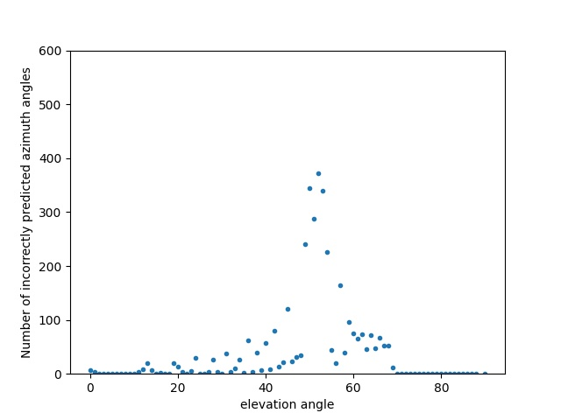

Figure 14. Elevation angles versus the number of incorrectly predicted azimuth angles for the first receiving system.

Table 2 Comparison of powers received by four strip dipole antennas in an ideal system and a system with noise..

|  |  |  |  |  |  |  |  |  |  |  |
| --- | --- | --- | --- | --- | --- | --- | --- | --- | --- | --- |
| True azimuth angle | Predicted azimuth angle | Elevation angle | $$P_{1}$$ | | $$P_{2}$$ | | $$P_{3}$$ | | $$P_{4}$$ | |
| without noise | With noise | without noise | With noise | without noise | With noise | without noise | With noise |
| 8° | 187° | 53° | 0.249414 | 0.249423 | 0.249990 | 0.250001 | 0.250435 | 0.250425 | 0.250158 | 0.250150 |
| 27° | 208° | 53° | 0.249503 | 0.249492 | 0.249800 | 0.249791 | 0.250409 | 0.250413 | 0.250286 | 0.250302 |
| 123° | 304° | 54° | 0.250521 | 0.250576 | 0.249235 | 0.249237 | 0.249542 | 0.249524 | 0.250700 | 0.250660 |
| 218° | 38° | 60° | 0.252623 | 0.252621 | 0.252169 | 0.252212 | 0.247323 | 0.247322 | 0.247884 | 0.247843 |

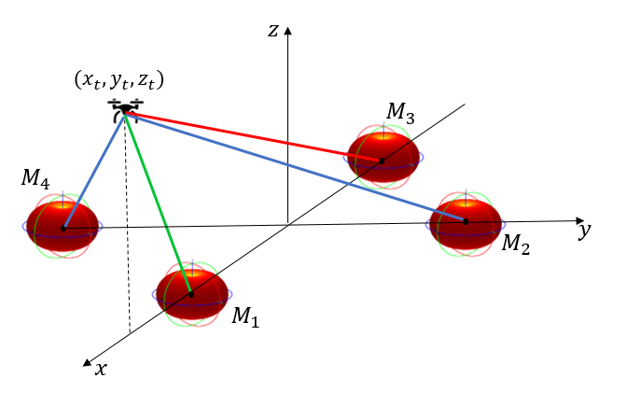

Figure 15. . Scenario formed by four receiving strip dipole antennas and a transmitting source located at 8° azimuth angle and 53° elevation within the receiving system.

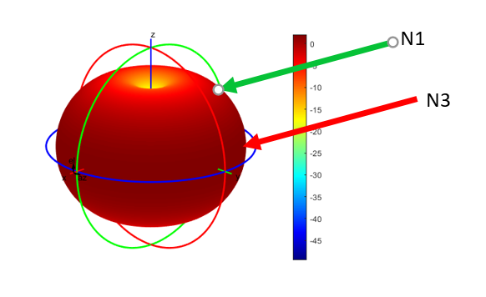

Figure 16. Radiation pattern of a strip dipole antenna.

Figure 16 shows a limited version of the confusion matrix with the 20 first classes. The figure shows a normal behavior in class classification, the model confuses the angles with those closest to it. The accuracy of the model predicting the azimuth angles is 78.54%.

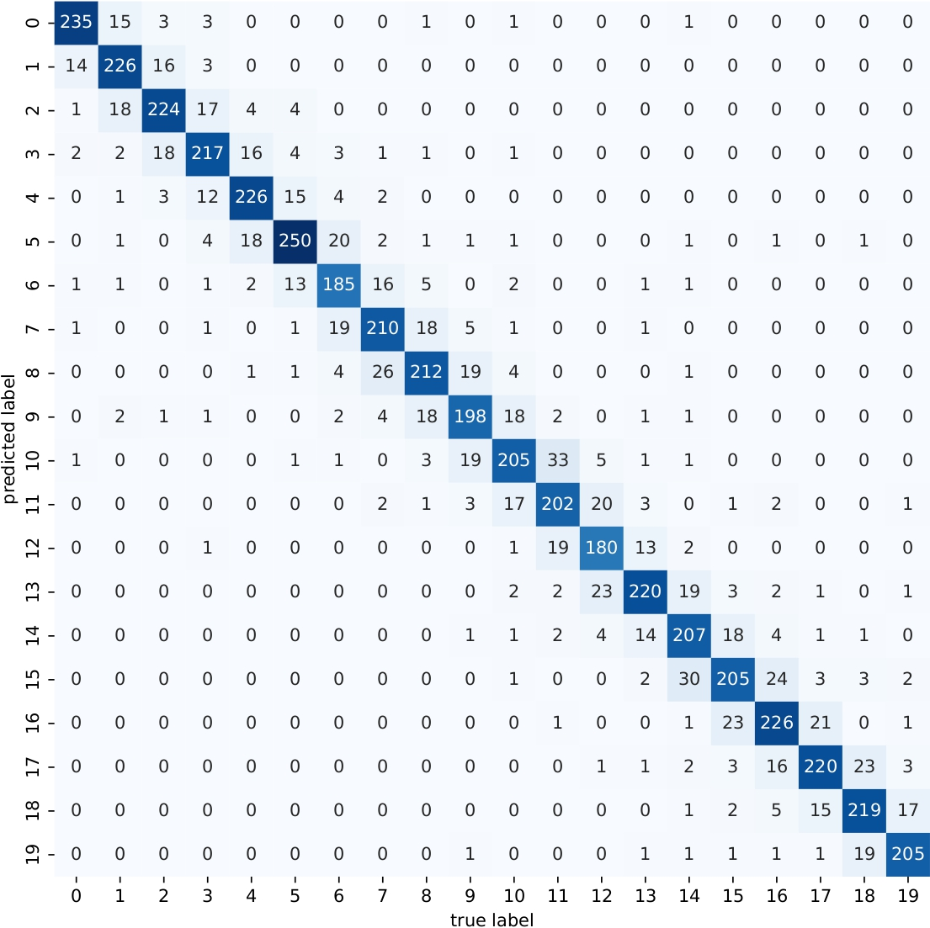

Figure 17. Confusion matrix with the first 20 classes for the azimuth angles of the DT model trained with the data provided by the first receiving system.

## ANALYSIS OF AZIMUTH ANGLES FOR THE SECOND RECEIVER SYSTEM MODEL

Figures 17 and 18 show that adding a strip dipole antenna at the center of the receiving system at a height of $r$ meters, decreases the error pattern shown in the previous section.

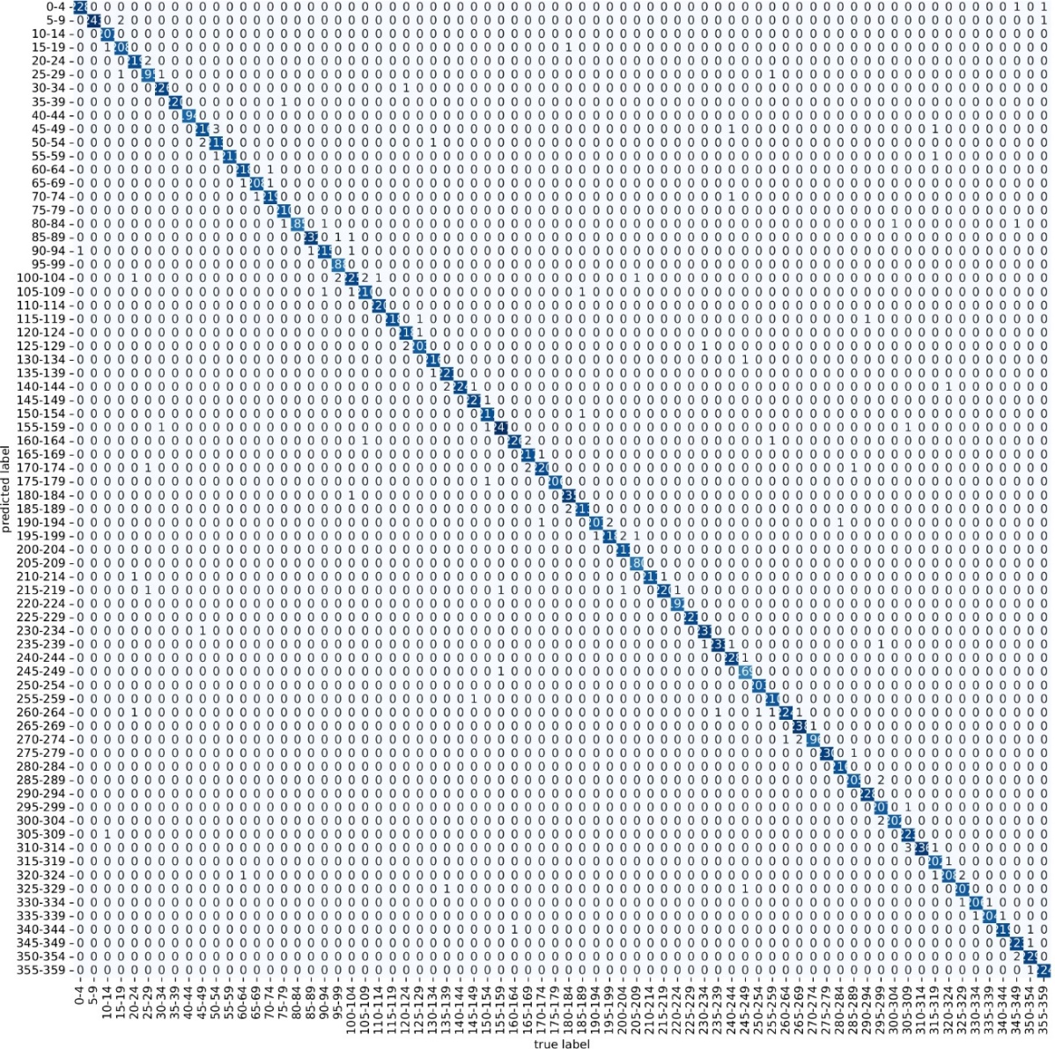

Figure 18. Confusion matrix of the DT model trained with the data provided by the second receiving system model.

Table 3 presents the powers for the second receiver model for the same azimuth and elevation angles presented in Table 2. The same behavior happens for the first four antennas as in the first receiving model. However, the power measured by the fifth antenna helps decrease the number of prediction errors.

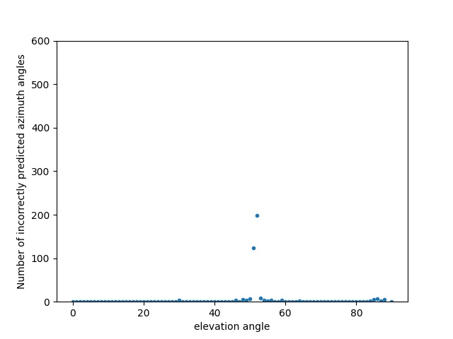

Figure 19. Elevation angles versus the number of incorrectly predicted azimuth angles with the second receiving system model.

Table 3. Comparison of received powers by five strip dipole antennas in an ideal system and a system with noise.

|  |  |  |  |  |  |  |  |  |  |  |  |  |
| --- | --- | --- | --- | --- | --- | --- | --- | --- | --- | --- | --- | --- |
| True azimuth angle | Predicted azimuth angle | Elevation angle | $$P_{1}$$ | | $$P_{2}$$ | | $$P_{3}$$ | | $$P_{4}$$ | | $$P_{5}$$ | |
| without noise | With noise | without noise | With noise | without noise | With noise | without noise | With noise | without noise | With noise |
| 8° | 6° | 53° | 0.197710 | 0.197715 | 0.198167 | 0.198173 | 0.19852 | 0.198510 | 0.198300 | 0.198292 | 0.207301 | 0.207308 |
| 27° | 29° | 53° | 0.19778118 | 0.197776 | 0.1980168 | 0.198013 | 0.198499 | 0.198505 | 0.19840212 | 0.19841 | 0.20730091 | 0.207286 |
| 123° | 125° | 54° | 0.19856876 | 0.198608 | 0.19754969 | 0.197547 | 0.19779352 | 0.197775 | 0.19871121 | 0.198675 | 0.20737681 | 0.207392 |
| 218° | 218° | 60° | 0.20013254 | 0.20014 | 0.19977308 | 0.199818 | 0.19593372 | 0.195944 | 0.19637842 | 0.196356 | 0.20778224 | 0.207737 |

Figure 19 shows a limited version of the confusion matrix with the 20 first classes. In the figure, it can be seen that the model also confuses the real angle with angles close to it, but in general, this does not happen. Therefore, this model obtained an accuracy of 79.05% for the azimuth angles.

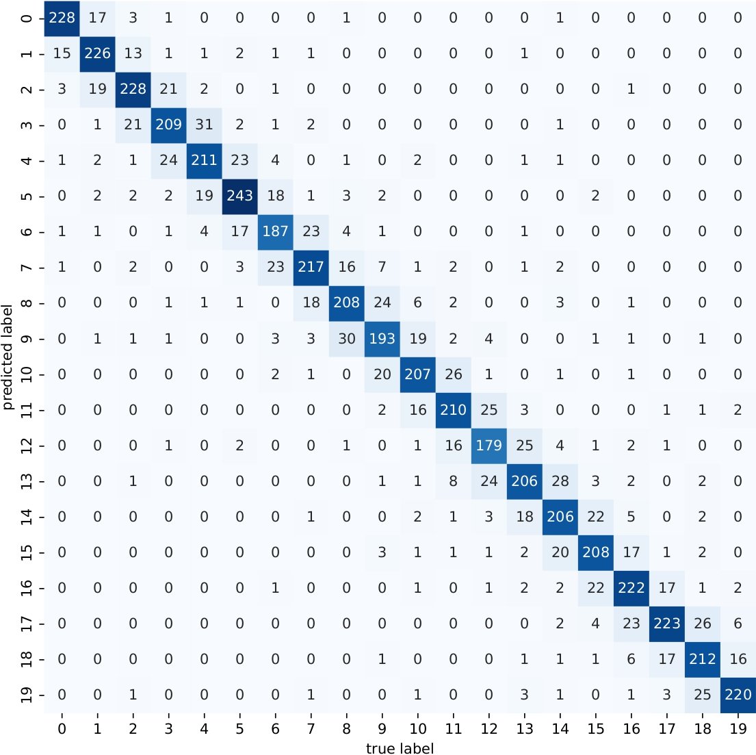

Figure 20. Confusion matrix with the first 20 classes of the DT model trained with the data provided by the second receiving system.

Appendix B shows the confusion matrices of the azimuth angles for the second receiving system with zero mean noise and variances of ${ 10}^{-7}$, ${ 10}^{-8}$, ${ 10}^{-9}$, ${ 10}^{-11}$, and ${ 10}^{-12}$, where the latter is corroborated.

## ANALYSIS OF AZIMUTH ANGLES FOR THE THIRD RECEIVER SYSTEM MODEL

Figure 20 shows the confusion matrix of the DT model trained with the data provided by the third receiving system model. Based on the confusion matrix and with the help of Figure 21, it can be seen that the azimuth angles for which the model has the worst resolution are the angles between 0°- 30°, 140° - 210°, and 325° - 359°, respectively. Figure 22 shows that these azimuth angles are situated where the directivity of the planar V-dipole antennas is lower (see Figure 12), therefore it is where the received powers are giving less information to the DT model.

Figure 23 shows that for the first 45° of elevation, the DT model makes more errors. This is explained by the radiation pattern of planar V-dipole antenna. When the elevation angle between the transmitter and the center of the system is between 0° and 45°, the directivity of the dipole Vee antenna is lower (as shown in Figure 24), therefore the powers measured by the receiving antennas are lower.

The precision of the DT model for the azimuth angles, with the data obtained with the third proposal of the receiving system, was 78.98%. This means that in terms of precision, this proposal is the one with the worst results to find the azimuth angle.

Appendix C shows the confusion matrices of the azimuth angles for the third receiving system with a noise of zero mean and variances of ${ 10}^{-7}$, ${ 10}^{-8}$, ${ 10}^{-9}$, ${ 10}^{-11}$, and ${ 10}^{-12}$ where the latter is corroborated.

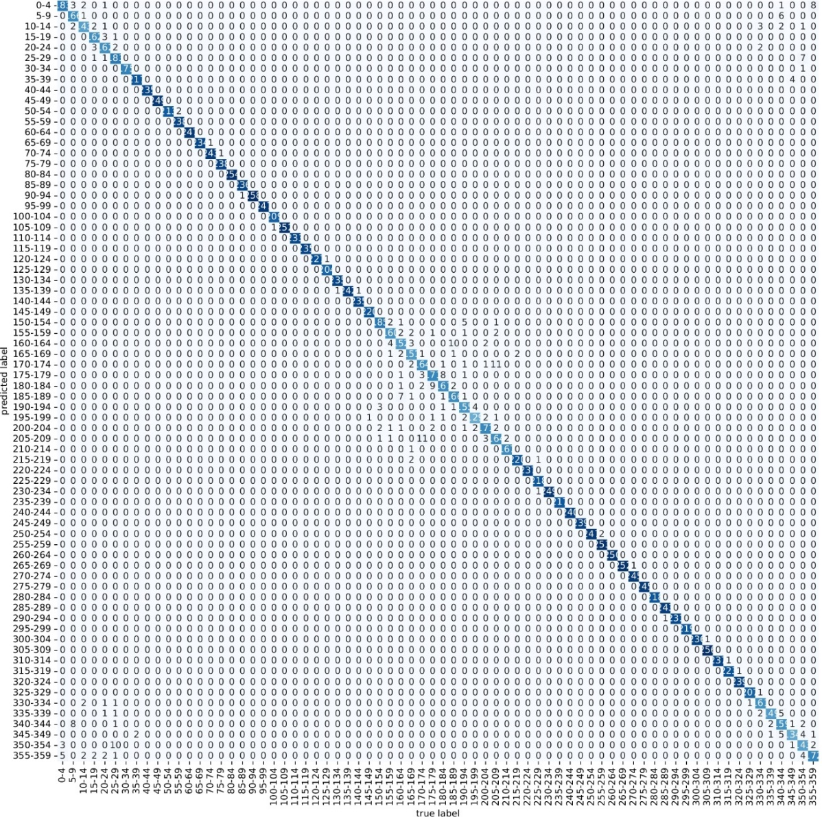

Figure 21. Confusion matrix of the DT model trained with the data provided by the third receiving system.

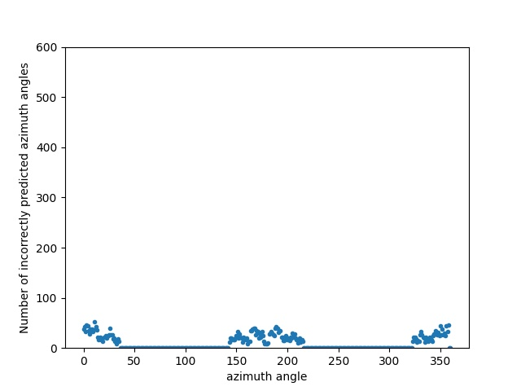

Figure 22. Azimuth angles versus a number of incorrectly predict azimuth angles in the third receiving system.

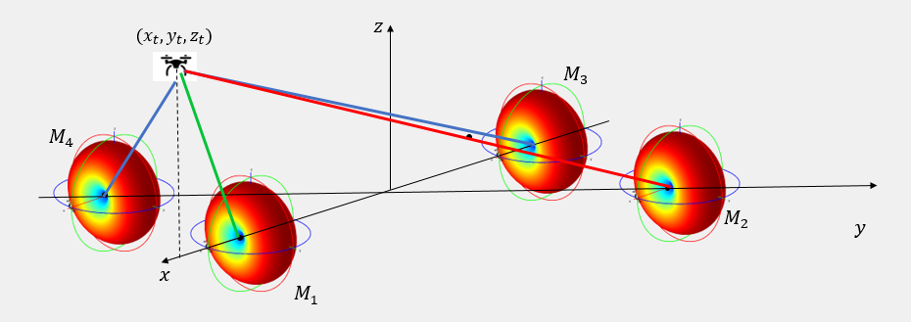

Figure 23. Scenario formed by four receiving antennas dipole Vee and a transmitting source located at 0*°* azimuth and 53*°* elevation angles within the receiving system.

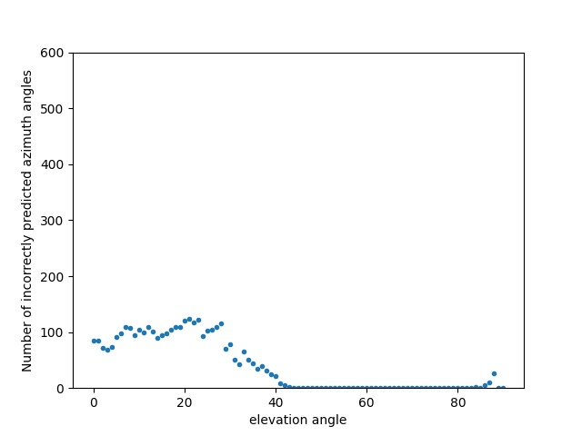

Figure 24. Elevation angles versus a number of incorrectly predict azimuth angles in the third receiving system.

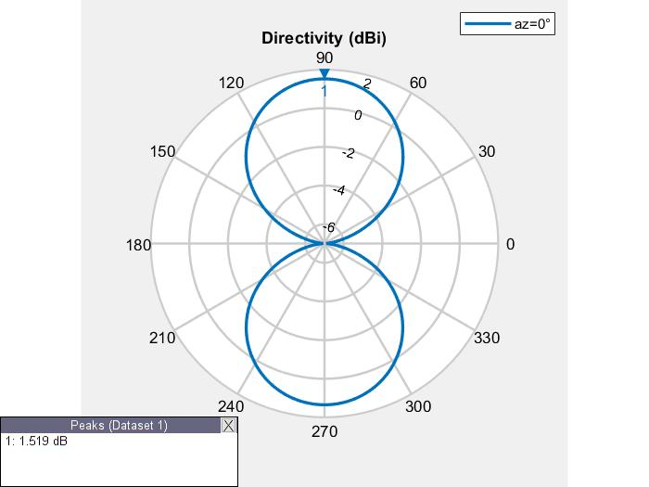

Figure 25. The radiation pattern of a dipole Vee antenna in xz-plane.

## ANALYSIS OF AZIMUTH ANGLES FOR THE FOURTH RECEIVER SYSTEM MODEL

When comparing Figures 20, 21, and 23 with Figures 25, 26, and 27 respectively, it can be seen that by adding a planar V-dipole antenna on the z-axis, the error pattern decreases considerably. Additionally, the accuracy obtained for the azimuth models with this database was 79.9%.

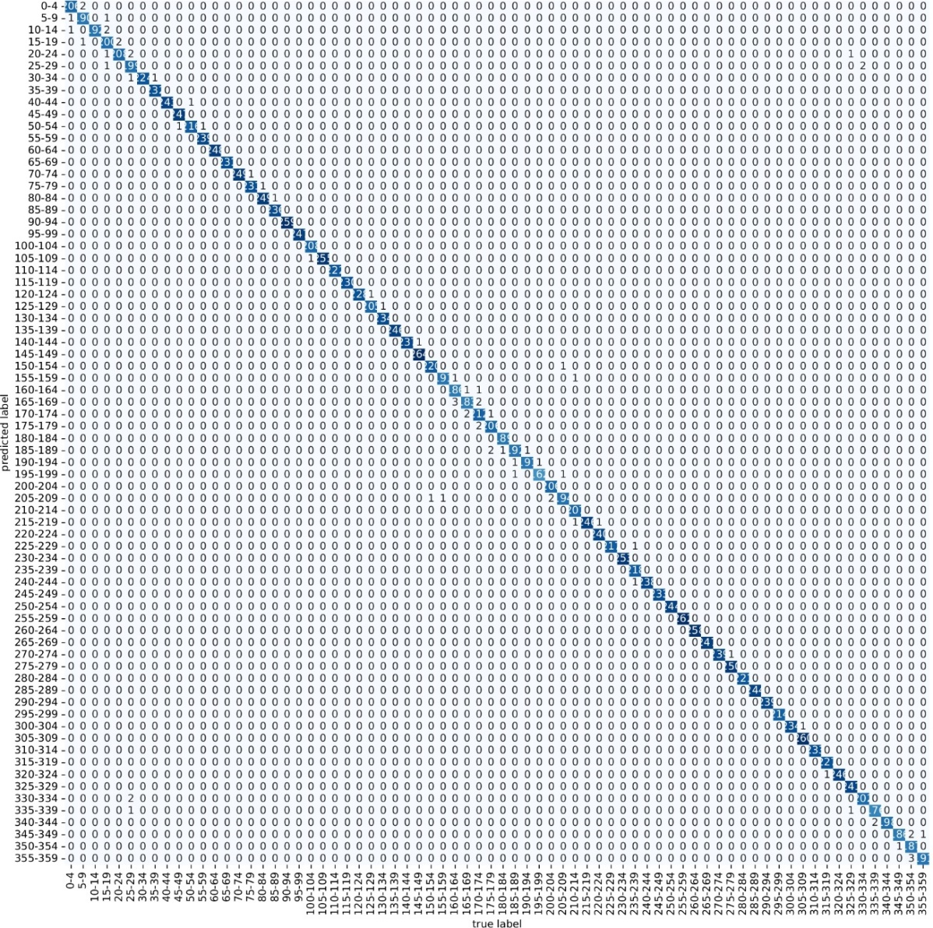

Figure 26. Confusion matrix of the DT model trained with the data provided by the fourth receiving system.

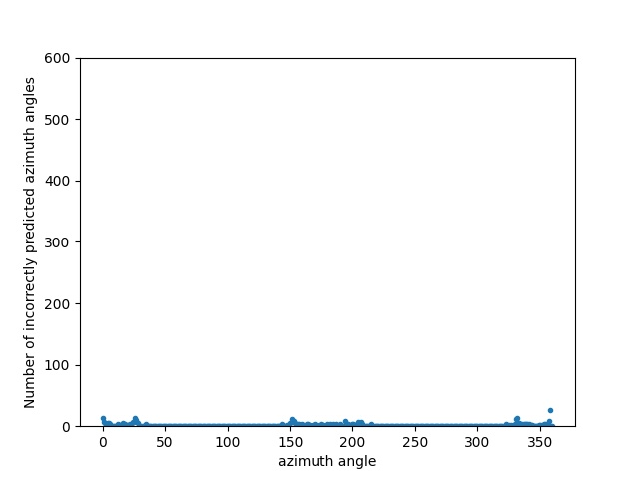

Figure 27. Azimuth angles versus a number of incorrectly predict azimuth angles in the fourth receiving system.

Appendix D shows the confusion matrices of the azimuth angles for the fourth receiving system with a noise of zero mean and variances of ${ 10}^{-7}$, ${ 10}^{-8}$, ${ 10}^{-9}$, ${ 10}^{-11}$, and ${ 10}^{-12}$.

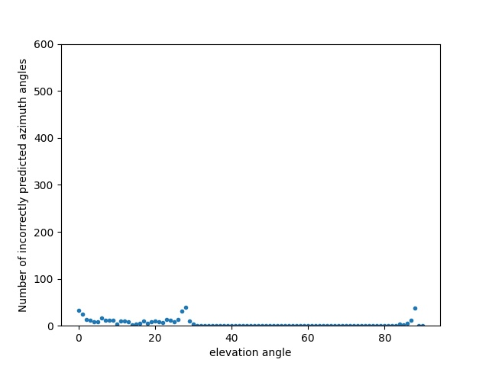

Figure 28. Elevation angles versus a number of incorrectly predict azimuth angles in the fourth receiving system.

## ANALYSIS OF ELEVATION ANGLES FOR THE FIRST RECEIVER SYSTEM MODEL

Figure 28 shows the confusion matrix for the elevation angles of the DT model trained with the data provided by the first receiving system. Additionally, Figure 29 shows which elevation angles are the most incorrectly predicted by the model. Both figures demonstrate that the model does not tend to correctly predict elevation angles around 45°.

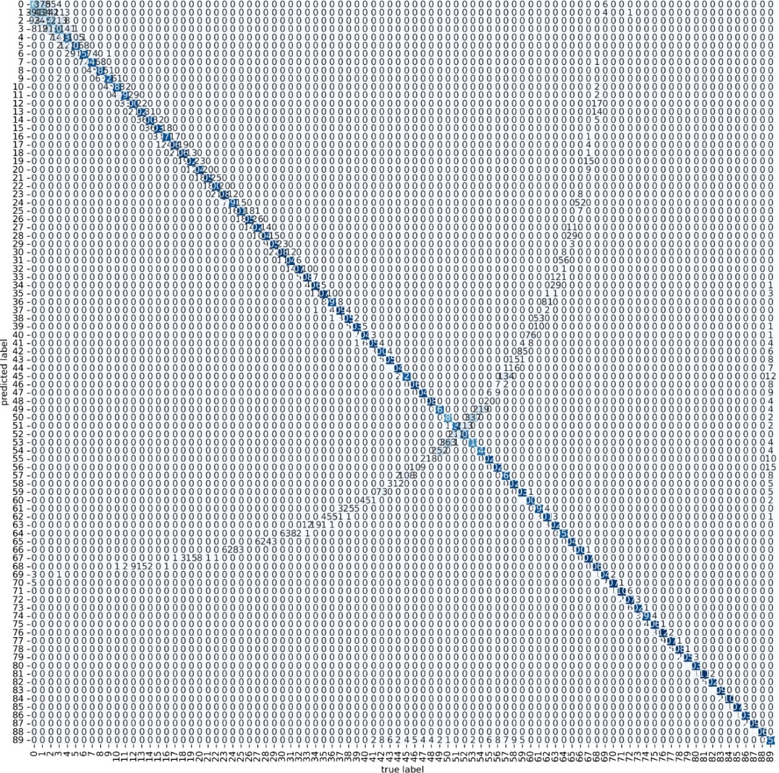

Figure 298. Confusion matrix for the elevation angles of the DT model trained with the data provided by the first receiving system.

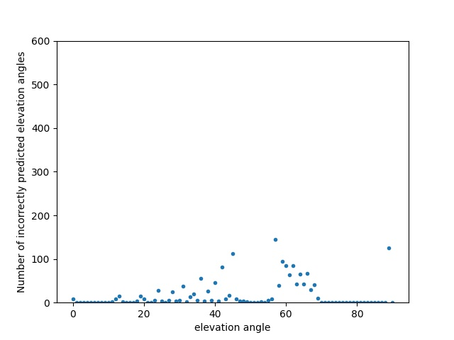

Figure 30. Elevation angles versus the number of incorrectly predicted elevation angles in the first system.

Figure 30 shows for which azimuth angles the DT model poorly predicts elevation angles. Figure 30 shows that for the azimuth angles around 45°, 135°, 225°, and 315° the DT model has worse resolution than the rest of the azimuth angles. The precision of the DT model to predict the elevation angles, with the data provided by the first receiver system proposed, is 92.31%.

Appendix E shows the confusion matrices of the elevation angles for the first receiving system with a noise of zero mean and variances of ${ 10}^{-7}$, ${ 10}^{-8}$, ${ 10}^{-9}$, ${ 10}^{-11}$, and ${ 10}^{-12}$ where the latter is corroborated.

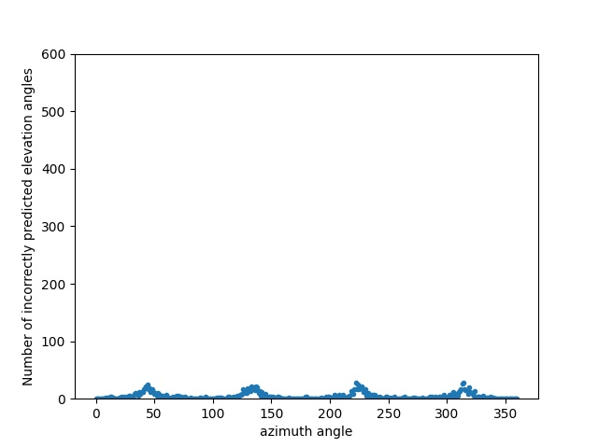

Figure 31. Azimuth angles versus the number of incorrectly predicted elevation angles in the first receiving system.

## ANALYSIS OF ELEVATION ANGLES FOR THE SECOND RECEIVER SYSTEM

When comparing Figures 28, 29, and 30 with Figures 31, 32, and 33 it is found that the pattern shown for the first receiving system is eliminated by adding another strip dipole antenna on the z-axis. The precision of the DT model to predict the elevation angles, with the data provided by the first receiver system proposed, is 99.3%. Appendix F shows the confusion matrices of the elevation angles for the second receiving system with a noise of zero mean and variances of ${ 10}^{-7}$, ${ 10}^{-8}$, ${ 10}^{-9}$, ${ 10}^{-11}$, and ${ 10}^{-12}$ where the latter is corroborated.

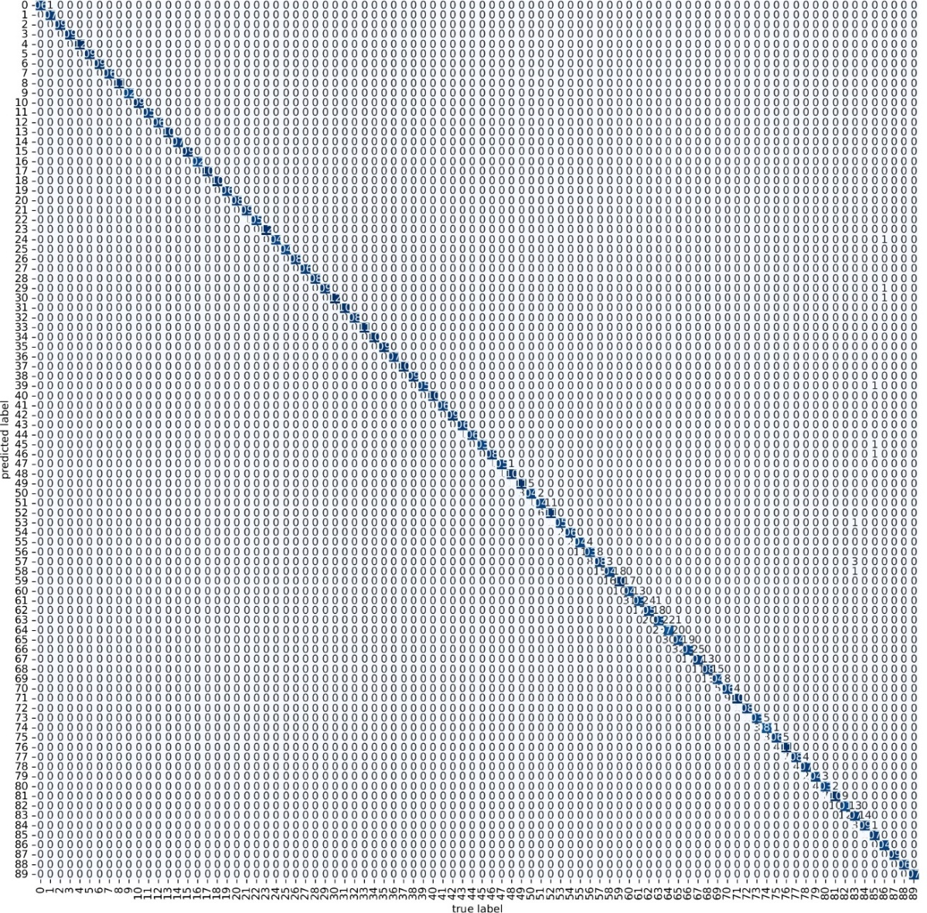

Figure 32. Confusion matrix for the elevation angles of the DT model trained with the data provided by the second receiving system.

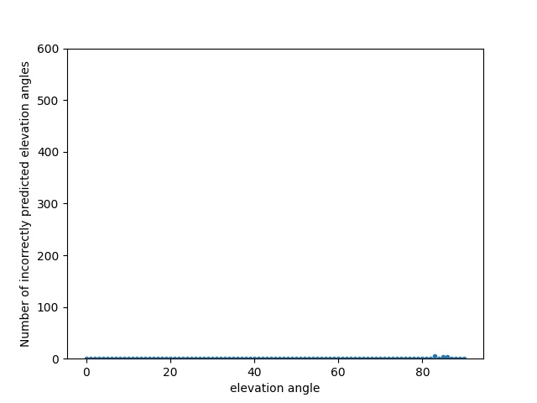

Figure 33. Elevation angles versus the number of incorrectly predicted elevation angles in the second receiving system.

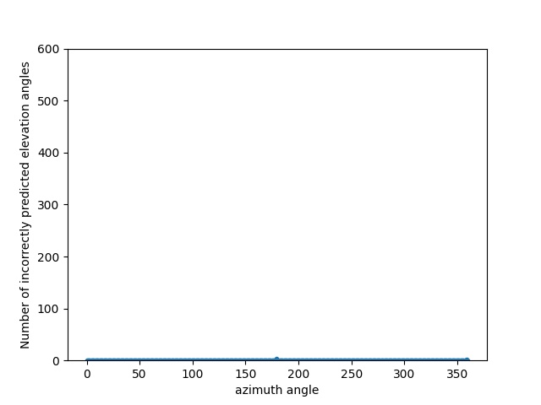

Figure 34. Azimuth angles versus the number of incorrectly predicted elevation angles in the second receiving system.

## ANALYSIS OF ELEVATION ANGLES FOR THE THIRD RECEIVER SYSTEM

Figure 34 shows the confusion matrix for the elevation angles of the DT model trained with the data provided by the third receiving system. Also, figure 35 shows the elevation angles versus the number of incorrectly predicted elevation angles in the third receiving system. In both figures, it can be seen that the DT model has a worse resolution for the first 40° of elevation than the rest. As shown in Figure 24, the planar V-dipole antenna has lower directivity when the elevation angle between the transmitter and the center of the system is between 0° and 45°. Therefore, the powers measured by the receiving antennas are lower when the elevation angle between the transmitter and the center of the receiving system is between 0° and 45°. Appendix G shows the confusion matrices of the elevation angles for the third receiving system with a noise of zero mean and variances of ${ 10}^{-7}$, ${ 10}^{-8}$, ${ 10}^{-9}$, ${ 10}^{-11}$, and ${ 10}^{-12}$.

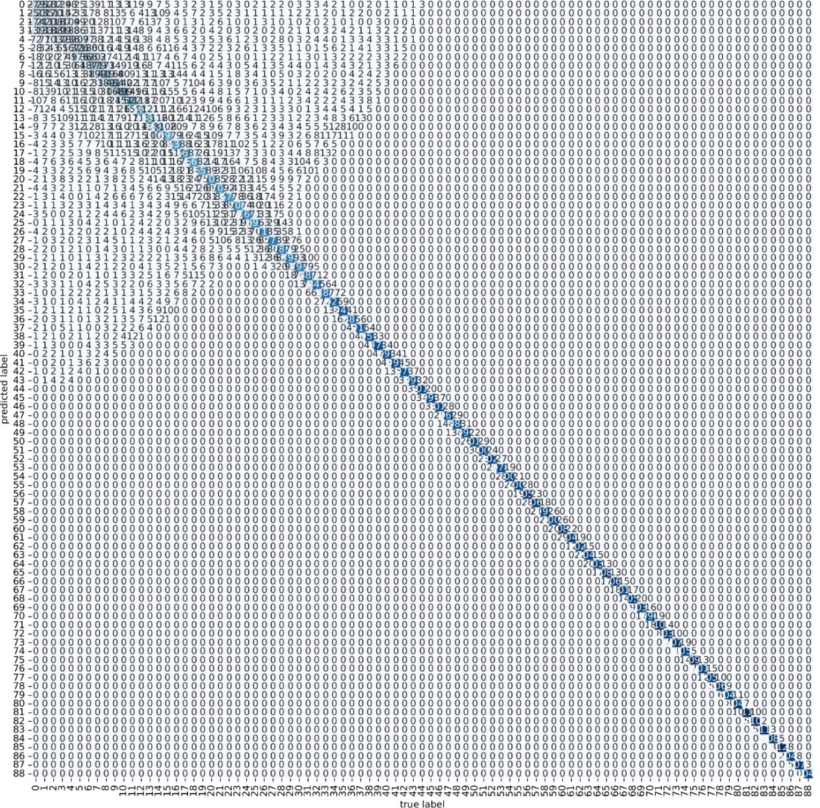

Figure 35. Confusion matrix for the elevation angles of the DT model trained with the data provided by the third receiving system.

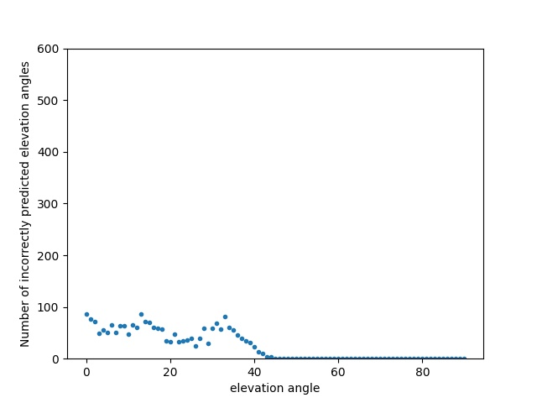

Figure 36. Elevation angles versus the number of incorrectly predicted elevation angles in the third receiving system.

Figure 36 shows that the azimuth angles for which the model has the worst resolution are the angles between 0° - 30°, 140° - 210°, and 325° - 359°. This is due to the same reason that was explained in subsection 4.4, in Figure 22. Figure 22 shows that these azimuth angles are situated where the directivity of the planar V-dipole antenna is lower, therefore it is where the received powers are giving less information to the DT model.

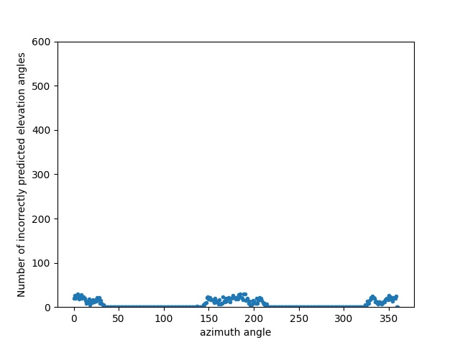

Figure 37. Azimuth angles versus the number of incorrectly predicted elevation angles in the third receiving system.

## ANALYSIS OF ELEVATION ANGLES FOR THE FOURTH RECEIVER SYSTEM

Figures 37 and 38 show that with the information provided by the fifth antenna to the DT model, its resolution for the first 40 elevation angles improves. Figure 38 shows that the number of errors in the prediction of elevation angles is relatively low. The same is seen in Figure 39, with the addition of a fifth antenna on the z-axis. The pattern where the model mispredicted elevation angles when azimuth angles were between 0° - 30°, 140° - 210°, and 325° - 359° is now virtually non-existent.

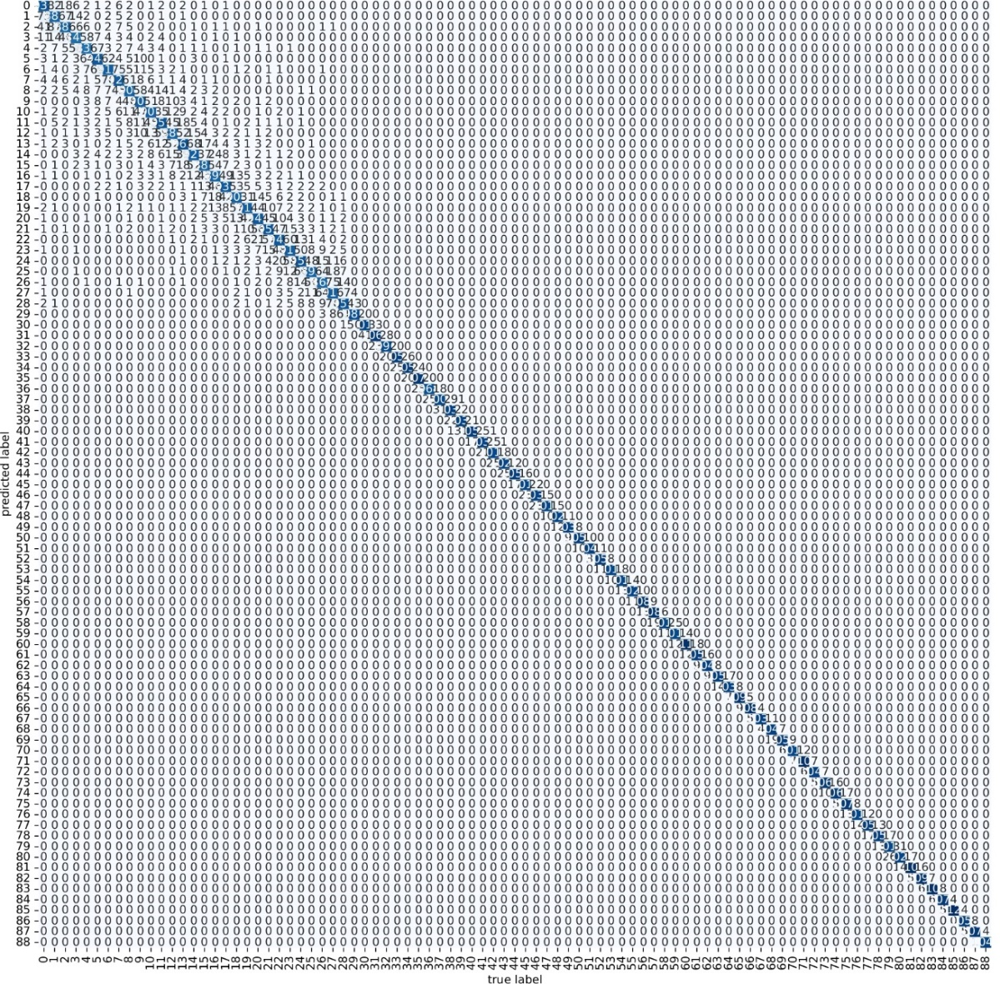

Figure 38. Confusion matrix for the elevation angles of the DT model trained with the data provided by the fourth receiving system.

Appendix H shows the confusion matrices of the elevation angles for the fourth receiving system with a noise of zero mean and variances of ${ 10}^{-7}$, ${ 10}^{-8}$, ${ 10}^{-9}$, ${ 10}^{-11}$, and ${ 10}^{-12}$ where the latter is corroborated.

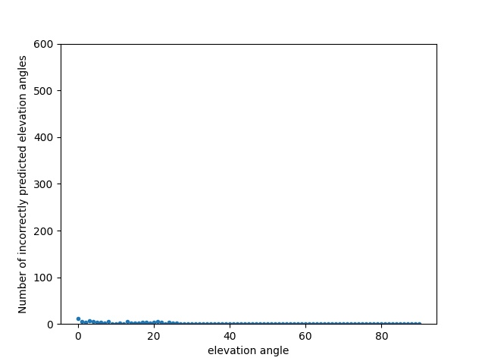

Figure 39. Elevation angles versus the number of incorrectly predicted elevation angles in the fourth receiving system.

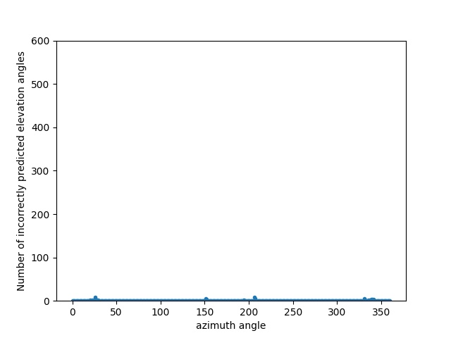

Figure 40. Azimuth angles versus the number of incorrectly predicted elevation angles in the fourth receiving system.

## PARTIAL CONCLUSIONS

This chapter demonstrates that the results of the ML models, specifically the DT model, will be dependent on the power information provided by the receiving system. This chapter proposes four models of receiving systems:

* First Receiver Model: Consists of four strip dipole antennas.
* Second Receiver Model: Consists of five strip dipole antennas.
* Third Receiver Model: Consists of four planar V-dipole antennas.
* Fourth Receiver Model: Consists of five planar V-dipole antennas.

To compare which receiving system was better to find the azimuth angle, the MMP proposal and the DT model were used. It is important to clarify that the DT model was not optimized since it was not the objective of this chapter and in the following one the optimization of the DT model and other ML models will be carried out.

The azimuth and elevation angles are in a range of [$0^{0},{360}^{0}$) and [$0^{0},{90}^{0}$), respectively with an angle resolution of $1^{0}$. For each angle pair, 15 normalized power measurement vectors were generated. From the total data, 80% was used to train the DT model, and the remaining 20% was used for the model validation.

With the data provided by the first receiving system proposal, the DT model confuses the real azimuth angles with those that are 180° apart from them. If one extra strip dipole antenna is added at the Cartesian point ($0.0,r$) this behavior is reduced, but is still present, reaching wrong predictions of up to 200 azimuth angles for elevation angles around 50°, as shown in Figure 22. On the other hand, the DT model, with the data obtained with the first receiver system proposal, also has an error pattern predicting the elevation angle. However, this pattern is completely eliminated by adding a strip dipole antenna on the z-axis (second receiving system).

When four planar V-dipole antennas are used (third receiving system proposal) the DT model has a worse resolution for azimuth angles between 0° - 30°, 140° - 210°, and 325° - 359°, and the first 40° elevation angles. This is due to the directivity of planar V-dipole antennas. However, with the fourth proposal, the resolution of the DT model increases for these angles.

Table 4 summarizes the accuracy and MSE of the DT model for each of the receiving systems. In the table, it is observed that the model obtains both better accuracy and MSE when it uses the data obtained by the fourth receiving system. Therefore, the authors of this thesis decide to use the fourth proposal as the receiving system for the rest of the document.

Table 4. Accuracy and MSE of the DT model with the data provided by the four proposed receiving systems.

|  |  |  |  |  |  |  |
| --- | --- | --- | --- | --- | --- | --- |
| Proposed receptor systems | Accuracy (%) | | | MSE | | |
| $${accuracy}_{MPP-ϕ}$$ | $${accuracy}_{MPP-θ}$$ | $${accuracy}_{MPP}$$ | $${MSE}_{MPP-ϕ}$$ | $${MSE}_{MPP-θ}$$ | $${MSE}_{MPP}$$ |
| First Receiver Model | 78.54 | 92.31 | 73.63 | 1383.78 | 16.07 | 1399.86 |
| Second Receiver Model | 79.05 | 99.30 | 78.58 | 386.86 | 0.20 | 387.06 |
| Third Receiver Model | 78.98 | 79.59 | 66.75 | 2021.22 | 12.02 | 2033.24 |
| Fourth Receiver Model | 84.16 | 93.15 | 79.92 | 249.45 | 0.5539 | 250.00 |

# CHAPTER 5: SIMULATION

In this chapter, the ML models proposed in Chapter 2.3 will be compared with each other along with other DOA methods proposed in the literature. Each model ML will be optimized and compared for both proposals presented in subchapter 2.1 (SP and MMP proposal).

## SIMULATIONS CONDITIONS

All ML models will be trained and validated with the data proposed by the receiver system proposed in Chapter 3 - $N$ dipole Vee antennas positioned forming a circle in the $xy$ plane and one dipole Vee antenna at the Cartesian point ( $0,0,r$) - The simulation scenario presented in Chapter 3 will generate the training data. This simulation scenario was implemented with Matlab.

Once the training data has been provided, the ML models and DOA methods proposed in the literature will be compared. The comparison will be made with the use of the python language. Both power generation and ML model comparison were performed on an Acer laptop with a Core i7 processor, 16 GB RAM, and 8 GB Intel(R) Iris(R) Xe Graphics video card.

## OPTIMIZATION OF MACHINE LEARNING MODELS

# CHAPTER 6: CONCLUSIONS

# APPENDIX A

# References

[1] Z. Zhang *et al.*, “6G Wireless Networks: Vision, Requirements, Architecture, and Key Technologies,” *IEEE Veh. Technol. Mag.*, vol. 14, no. 3, pp. 28–41, Sep. 2019, doi: 10.1109/MVT.2019.2921208.

[2] B. Zong, C. Fan, X. Wang, X. Duan, B. Wang, and J. Wang, “6G Technologies: Key Drivers, Core Requirements, System Architectures, and Enabling Technologies,” *IEEE Veh. Technol. Mag.*, vol. 14, no. 3, pp. 18–27, Sep. 2019, doi: 10.1109/MVT.2019.2921398.

[3] M. Z. Chowdhury, Md. Shahjalal, S. Ahmed, and Y. M. Jang, “6G Wireless Communication Systems: Applications, Requirements, Technologies, Challenges, and Research Directions,” *IEEE Open J. Commun. Soc.*, vol. 1, pp. 957–975, 2020, doi: 10.1109/OJCOMS.2020.3010270.

[4] S. Elmeadawy and R. M. Shubair, “Enabling Technologies For 6g Future Wireless Communications: Opportunities And Challenges,” *ArXiv200206068 Eess*, Feb. 2020, Accessed: May 12, 2021. [Online]. Available: http://arxiv.org/abs/2002.06068

[5] R. Avtar and T. Watanabe, Eds., *Unmanned Aerial Vehicle: Applications in Agriculture and Environment*. Cham: Springer International Publishing, 2020. doi: 10.1007/978-3-030-27157-2.

[6] M. S. Allahham, T. Khattab, and A. Mohamed, “Deep Learning for RF-Based Drone Detection and Identification: A Multi-Channel 1-D Convolutional Neural Networks Approach,” in *2020 IEEE International Conference on Informatics, IoT, and Enabling Technologies (ICIoT)*, Doha, Qatar, Feb. 2020, pp. 112–117. doi: 10.1109/ICIoT48696.2020.9089657.

[7] H. Shakhatreh *et al.*, “Unmanned Aerial Vehicles (UAVs): A Survey on Civil Applications and Key Research Challenges,” *IEEE Access*, vol. 7, pp. 48572–48634, 2019, doi: 10.1109/ACCESS.2019.2909530.

[8] “Drone That Crashed at White House Was Quadcopter,” *Time*. https://time.com/3682307/white-house-drone-crash/ (accessed Mar. 25, 2022).

[9] “Lufthansa jet and drone nearly collide near LAX - Los Angeles Times.” https://www.latimes.com/local/lanow/la-me-ln-drone-near-miss-lax-20160318-story.html (accessed May 13, 2021).

[10] T. S. B. of C. Government of Canada, “Aviation transportation safety investigation report A17Q0162,” Feb. 14, 2018. https://www.tsb.gc.ca/eng/rapports-reports/aviation/2017/a17q0162/a17q0162.html (accessed Mar. 25, 2022).

[11] R. K. Miranda, D. A. Ando, J. P. C. L. da Costa, and M. T. de Oliveira, “Enhanced Direction of Arrival Estimation via Received Signal Strength of Directional Antennas,” in *2018 IEEE International Symposium on Signal Processing and Information Technology (ISSPIT)*, Louisville, KY, USA, Dec. 2018, pp. 162–167. doi: 10.1109/ISSPIT.2018.8642668.

[12] “A SIGNAL SUBSPACE APPROACH TO MULTIPLE EMITTER LOCATION AND SPECTRAL ESTIMATION - ProQuest.” https://www.proquest.com/openview/ed9b03e77117e41780070bd1ceacea3b/1?pq-origsite=gscholar&cbl=18750&diss=y (accessed May 03, 2022).

[13] J. W. Paik, K.-H. Lee, and J.-H. Lee, “Asymptotic Performance Analysis of Maximum Likelihood Algorithm for Direction-of-Arrival Estimation: Explicit Expression of Estimation Error and Mean Square Error,” *Appl. Sci.*, vol. 10, no. 7, Art. no. 7, Jan. 2020, doi: 10.3390/app10072415.

[14] M. Pesavento and A. B. Gershman, “Maximum-likelihood direction-of-arrival estimation in the presence of unknown nonuniform noise,” *IEEE Trans. Signal Process.*, vol. 49, no. 7, pp. 1310–1324, Jul. 2001, doi: 10.1109/78.928686.

[15] F. Athley, “Threshold region performance of maximum likelihood direction of arrival estimators,” *IEEE Trans. Signal Process.*, vol. 53, no. 4, pp. 1359–1373, Apr. 2005, doi: 10.1109/TSP.2005.843717.

[16] M. Wax and T. Kailath, “Detection of signals by information theoretic criteria,” *IEEE Trans. Acoust. Speech Signal Process.*, vol. 33, no. 2, pp. 387–392, Apr. 1985, doi: 10.1109/TASSP.1985.1164557.

[17] Y.-Y. Dong, C.-X. Dong, W. Liu, and M.-M. Liu, “DOA estimation with known waveforms in the presence of unknown time delays and Doppler shifts,” *Signal Process.*, vol. 166, p. 107232, Jan. 2020, doi: 10.1016/j.sigpro.2019.07.025.

[18] M. Pesavento and A. B. Gershman, “Maximum-likelihood direction-of-arrival estimation in the presence of unknown nonuniform noise,” *IEEE Trans. Signal Process.*, vol. 49, no. 7, pp. 1310–1324, Jul. 2001, doi: 10.1109/78.928686.

[19] R. Pohlmann, S. Zhang, T. Jost, and A. Dammann, “Power-based direction-of-arrival estimation using a single multi-mode antenna,” in *2017 14th Workshop on Positioning, Navigation and Communications (WPNC)*, Bremen, Oct. 2017, pp. 1–6. doi: 10.1109/WPNC.2017.8250056.

[20] D. Manteuffel and R. Martens, “Compact Multimode Multielement Antenna for Indoor UWB Massive MIMO,” *IEEE Trans. Antennas Propag.*, vol. 64, no. 7, pp. 2689–2697, Jul. 2016, doi: 10.1109/TAP.2016.2537388.

[21] F. Wen, P. Liu, H. Wei, Y. Zhang, and R. C. Qiu, “Joint Azimuth, Elevation, and Delay Estimation for 3-D Indoor Localization,” *IEEE Trans. Veh. Technol.*, vol. 67, no. 5, pp. 4248–4261, May 2018, doi: 10.1109/TVT.2018.2794322.

[22] P. Stoica and K. C. Sharman, “Maximum likelihood methods for direction-of-arrival estimation,” *IEEE Trans. Acoust. Speech Signal Process.*, vol. 38, no. 7, pp. 1132–1143, Jul. 1990, doi: 10.1109/29.57542.

[23] X. Xu, X. Wei, and Z. Ye, “DOA Estimation Based on Sparse Signal Recovery Utilizing Weighted $l_{1}$-Norm Penalty,” *IEEE Signal Process. Lett.*, vol. 19, no. 3, pp. 155–158, Mar. 2012, doi: 10.1109/LSP.2012.2183592.

[24] D. Malioutov, M. Cetin, and A. S. Willsky, “A sparse signal reconstruction perspective for source localization with sensor arrays,” *IEEE Trans. Signal Process.*, vol. 53, no. 8, pp. 3010–3022, Aug. 2005, doi: 10.1109/TSP.2005.850882.

[25] M. S. Lobo, L. Vandenberghe, S. Boyd, and H. Lebret, “Applications of second-order cone programming,” *Linear Algebra Its Appl.*, vol. 284, no. 1–3, pp. 193–228, Nov. 1998, doi: 10.1016/S0024-3795(98)10032-0.

[26] V. Cevher, A. C. Gurbuz, J. H. McClellan, and R. Chellappa, “Compressive wireless arrays for bearing estimation,” in *2008 IEEE International Conference on Acoustics, Speech and Signal Processing*, Las Vegas, NV, USA, Mar. 2008, pp. 2497–2500. doi: 10.1109/ICASSP.2008.4518155.

[27] C. Zheng, G. Li, H. Zhang, and X. Wang, “An approach of DOA estimation using noise subspace weighted &#x2113;1 minimization,” in *2011 IEEE International Conference on Acoustics, Speech and Signal Processing (ICASSP)*, Prague, Czech Republic, May 2011, pp. 2856–2859. doi: 10.1109/ICASSP.2011.5947080.

[28] J. Dai, D. Zhao, and X. Ji, “A Sparse Representation Method for DOA Estimation With Unknown Mutual Coupling,” *IEEE Antennas Wirel. Propag. Lett.*, vol. 11, pp. 1210–1213, 2012, doi: 10.1109/LAWP.2012.2223651.

[29] X. Zhang, T. Jiang, Y. Li, and Y. Zakharov, “A Novel Block Sparse Reconstruction Method for DOA Estimation With Unknown Mutual Coupling,” *IEEE Commun. Lett.*, vol. 23, no. 10, pp. 1845–1848, Oct. 2019, doi: 10.1109/LCOMM.2019.2929384.

[30] H. Fu, S. Abeywickrama, C. Yuen, and M. Zhang, “A Robust Phase-Ambiguity-Immune DOA Estimation Scheme for Antenna Array,” *IEEE Trans. Veh. Technol.*, vol. 68, no. 7, pp. 6686–6696, Jul. 2019, doi: 10.1109/TVT.2019.2916171.

[31] E. J. Candes, J. Romberg, and T. Tao, “Robust uncertainty principles: exact signal reconstruction from highly incomplete frequency information,” *IEEE Trans. Inf. Theory*, vol. 52, no. 2, pp. 489–509, Feb. 2006, doi: 10.1109/TIT.2005.862083.

[32] Z. Liu, C. Zhang, and P. S. Yu, “Direction-of-Arrival Estimation Based on Deep Neural Networks With Robustness to Array Imperfections,” *IEEE Trans. Antennas Propag.*, vol. 66, no. 12, pp. 7315–7327, Dec. 2018, doi: 10.1109/TAP.2018.2874430.

[33] K. Terabayashi, R. Natsuaki, and A. Hirose, “Ultrawideband Direction-of-Arrival Estimation Using Complex-Valued Spatiotemporal Neural Networks,” *IEEE Trans. Neural Netw. Learn. Syst.*, vol. 25, no. 9, pp. 1727–1732, Sep. 2014, doi: 10.1109/TNNLS.2014.2313869.

[34] X. Xiao, S. Zhao, X. Zhong, D. L. Jones, E. S. Chng, and H. Li, “A learning-based approach to direction of arrival estimation in noisy and reverberant environments,” in *2015 IEEE International Conference on Acoustics, Speech and Signal Processing (ICASSP)*, Apr. 2015, pp. 2814–2818. doi: 10.1109/ICASSP.2015.7178484.

[35] Y. Kase, T. Nishimura, T. Ohgane, Y. Ogawa, D. Kitayama, and Y. Kishiyama, “DOA Estimation of Two Targets with Deep Learning,” in *2018 15th Workshop on Positioning, Navigation and Communications (WPNC)*, Oct. 2018, pp. 1–5. doi: 10.1109/WPNC.2018.8555814.

[36] A. Barthelme and W. Utschick, “A Machine Learning Approach to DoA Estimation and Model Order Selection for Antenna Arrays with Subarray Sampling,” *ArXiv200912858 Eess*, Sep. 2020, Accessed: Jan. 26, 2021. [Online]. Available: http://arxiv.org/abs/2009.12858

[37] Y. Guo, Z. Zhang, Y. Huang, and P. Zhang, “DOA Estimation Method Based on Cascaded Neural Network for Two Closely Spaced Sources,” *IEEE Signal Process. Lett.*, vol. 27, pp. 570–574, 2020, doi: 10.1109/LSP.2020.2984914.

[38] H. Huang, J. Yang, H. Huang, Y. Song, and G. Gui, “Deep Learning for Super-Resolution Channel Estimation and DOA Estimation Based Massive MIMO System,” *IEEE Trans. Veh. Technol.*, vol. 67, no. 9, pp. 8549–8560, Sep. 2018, doi: 10.1109/TVT.2018.2851783.

[39] S. Abeywickrama, L. Jayasinghe, H. Fu, S. Nissanka, and C. Yuen, “RF-based Direction Finding of UAVs Using DNN,” in *2018 IEEE International Conference on Communication Systems (ICCS)*, Chengdu, China, Dec. 2018, pp. 157–161. doi: 10.1109/ICCS.2018.8689177.

[40] M. Pastorino and A. Randazzo, “A smart antenna system for direction of arrival estimation based on a support vector regression,” *IEEE Trans. Antennas Propag.*, vol. 53, no. 7, pp. 2161–2168, Jul. 2005, doi: 10.1109/TAP.2005.850735.

[41] A. Randazzo, M. A. Abou-Khousa, M. Pastorino, and R. Zoughi, “Direction of Arrival Estimation Based on Support Vector Regression: Experimental Validation and Comparison With MUSIC,” *IEEE Antennas Wirel. Propag. Lett.*, vol. 6, pp. 379–382, 2007, doi: 10.1109/LAWP.2007.903491.

[42] M. Donelli, F. Viani, P. Rocca, and A. Massa, “An Innovative Multiresolution Approach for DOA Estimation Based on a Support Vector Classification,” *IEEE Trans. Antennas Propag.*, vol. 57, no. 8, pp. 2279–2292, Aug. 2009, doi: 10.1109/TAP.2009.2024485.

[43] J. Pan, Y. Wang, C. Le Bastard, and T. Wang, “DOA Finding with Support Vector Regression Based Forward–Backward Linear Prediction,” *Sensors*, vol. 17, no. 6, Art. no. 6, Jun. 2017, doi: 10.3390/s17061225.

[44] Z.-T. Huang, L.-L. Wu, and Z.-M. Liu, “Toward wide-frequency-range direction finding with support vector regression,” *IEEE Commun. Lett.*, vol. 23, no. 6, pp. 1029–1032, 2019.

[45] L.-L. Wu and Z.-T. Huang, “Coherent SVR Learning for Wideband Direction-of-Arrival Estimation,” *IEEE Signal Process. Lett.*, vol. 26, no. 4, pp. 642–646, Apr. 2019, doi: 10.1109/LSP.2019.2901641.

[46] M.-Y. You, A.-N. Lu, Y.-X. Ye, K. Huang, and B. Jiang, “A Review on Machine Learning-Based Radio Direction Finding,” *Math. Probl. Eng.*, vol. 2020, pp. 1–9, Aug. 2020, doi: 10.1155/2020/8345413.

[47] “scikit-learn: machine learning in Python — scikit-learn 0.24.2 documentation.” https://scikit-learn.org/stable/ (accessed May 12, 2021).

[48] “1.4. Support Vector Machines — scikit-learn 0.24.2 documentation.” https://scikit-learn.org/stable/modules/svm.html (accessed May 12, 2021).

[49] J. Stuart, “Russell & Peter Norvig: Artificial Intelligence: A Modern Approach,” *Prentice-Hall*, 2003.

[50] “1.10. Decision Trees — scikit-learn 0.24.1 documentation.” https://scikit-learn.org/stable/modules/tree.html (accessed Mar. 23, 2021).

[51] “sklearn.tree.ExtraTreeClassifier — scikit-learn 0.24.2 documentation.” https://scikit-learn.org/stable/modules/generated/sklearn.tree.ExtraTreeClassifier.html#sklearn.tree.ExtraTreeClassifier (accessed May 24, 2021).

[52] “sklearn.ensemble.BaggingClassifier — scikit-learn 0.24.1 documentation.” https://scikit-learn.org/stable/modules/generated/sklearn.ensemble.BaggingClassifier.html (accessed Mar. 23, 2021).

[53] D. Singh and B. Singh, “Investigating the impact of data normalization on classification performance,” *Appl. Soft Comput.*, vol. 97, p. 105524, Dec. 2020, doi: 10.1016/j.asoc.2019.105524.

[54] B. R. Jackson, S. Rajan, B. J. Liao, and S. Wang, “Direction of Arrival Estimation Using Directive Antennas in Uniform Circular Arrays,” *IEEE Trans. Antennas Propag.*, vol. 63, no. 2, pp. 736–747, Feb. 2015, doi: 10.1109/TAP.2014.2384044.